Bruno Munari

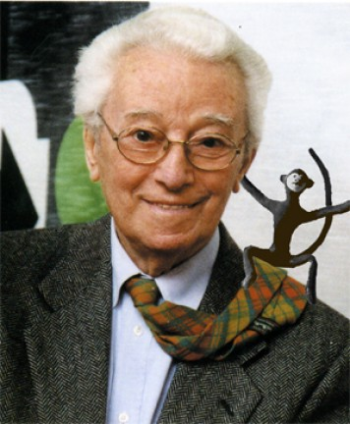

Bruno Munari was born in Milan in 1907. He started to work with his uncle who was an engineer. Then he worked as a press graphic designer and as art director. At the same time he began designing books for children, originally created for his son Alberto.
He was sculptor, painter, film maker too.
In 1930 Munari created Useless Machines, constructed of painted cardboard and other lightweight materials. They served to liberate abstract forms in three dimensions.
After World War II Munari concentrated on industrial design. An early example is X Hour, an alarm clock. Another object by Munari was a flexible metal wire structure that could be set in any number of positions.
He began to design and produce book-objects too. His children’s books were simple, provocative learning tools. In 1950 Munari began to experiment with light projection through coloured plastic to create coloured-light compositions.
He created toys and in 1954 he won the prize called “IL COMPASSO D’ORO” by Zizì, a foam-rubber monkey.
Munari died eleven years ago, in 1998.

We show you some children books written by Munari.
We tried to draw as him.

By Munari

Easy English Lesson
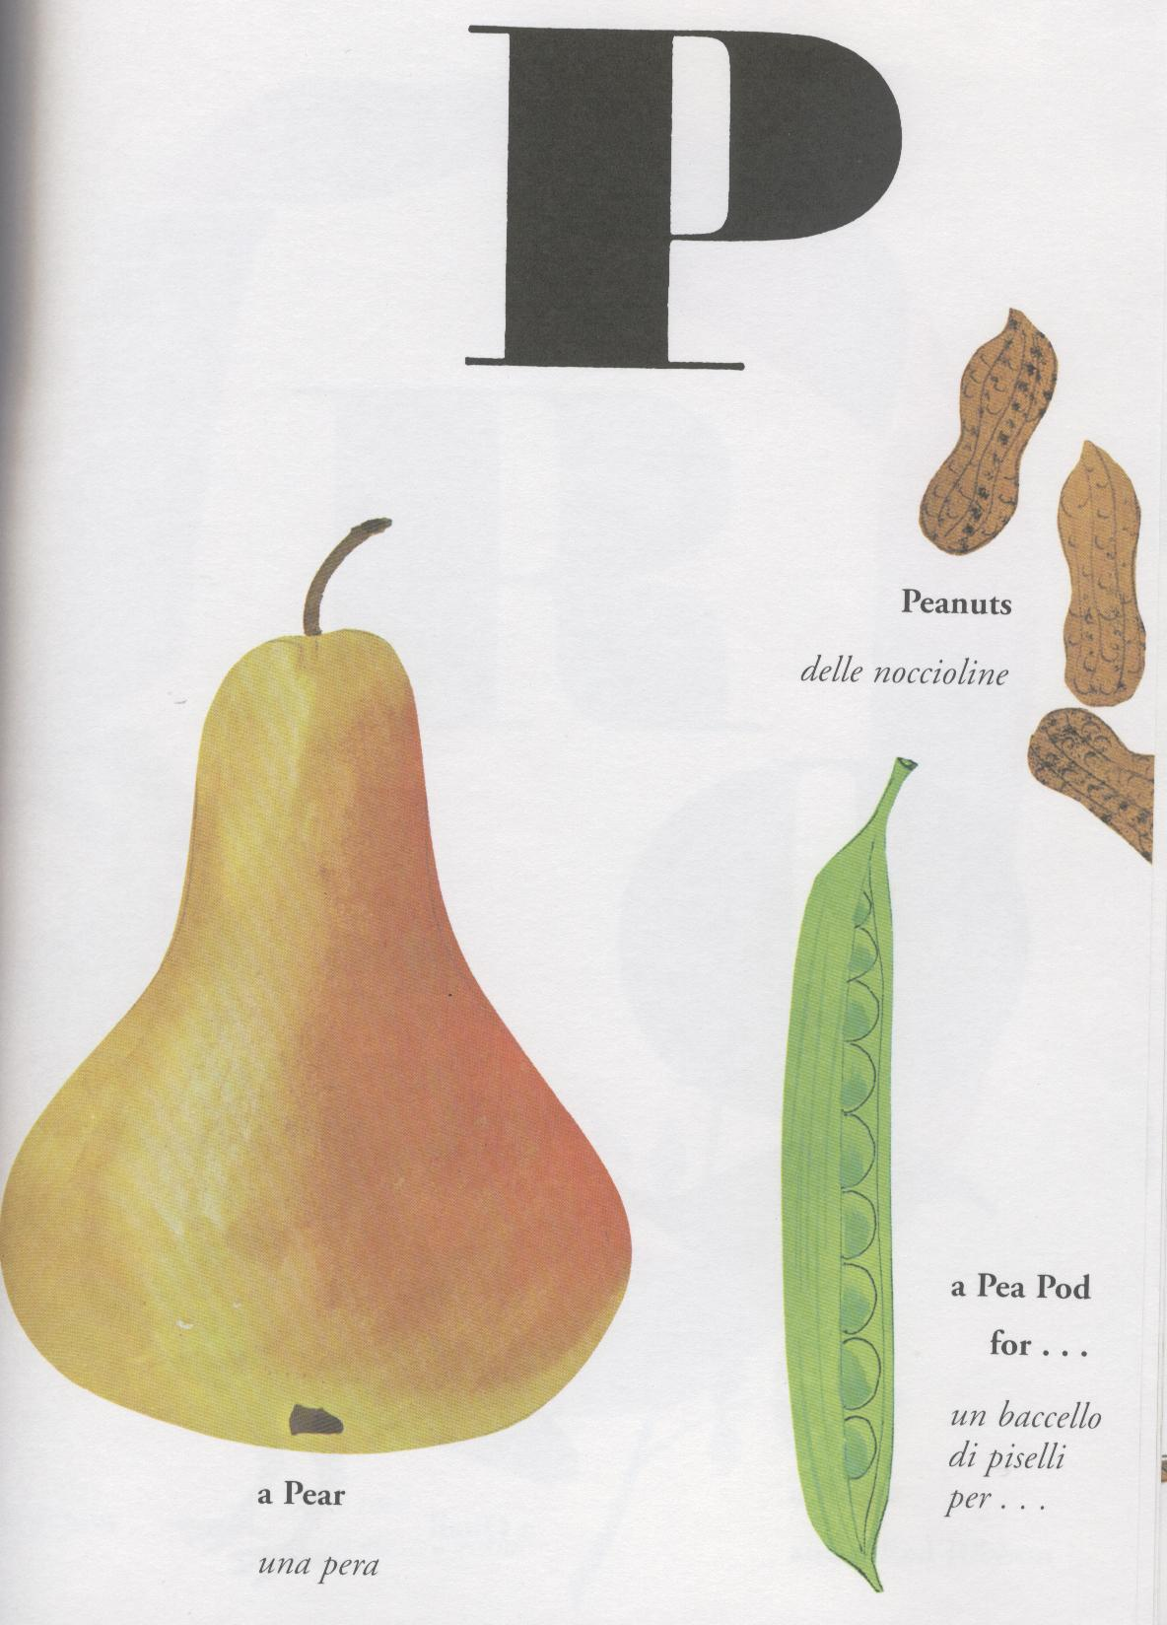

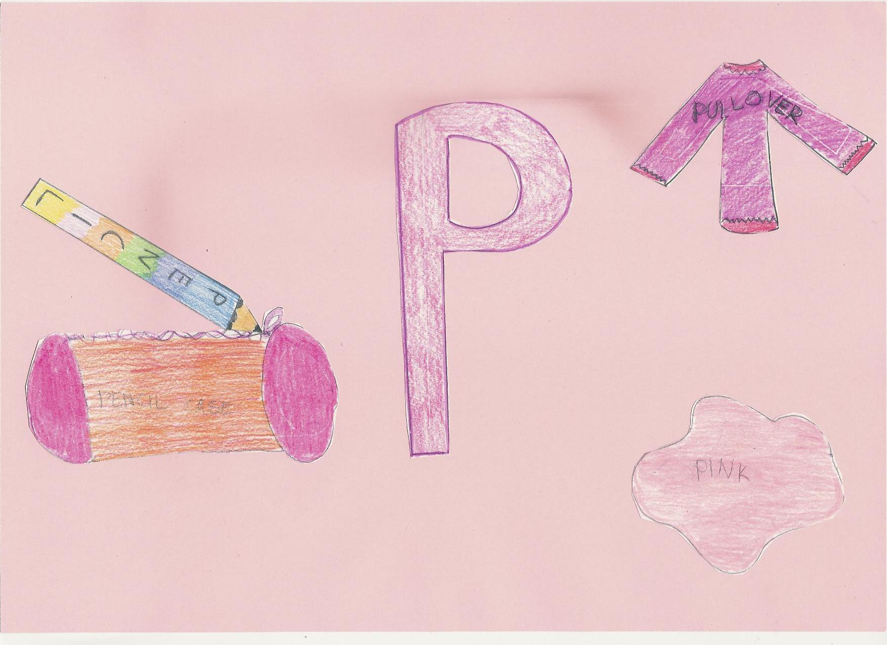
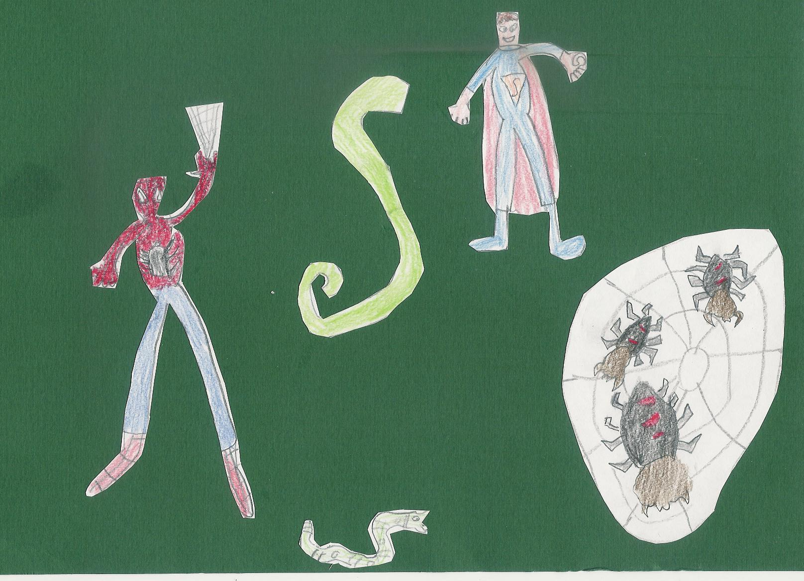
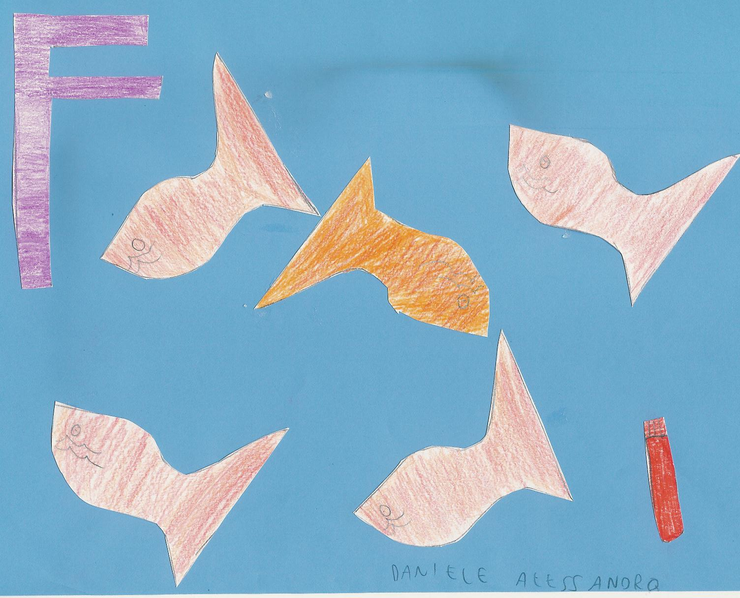
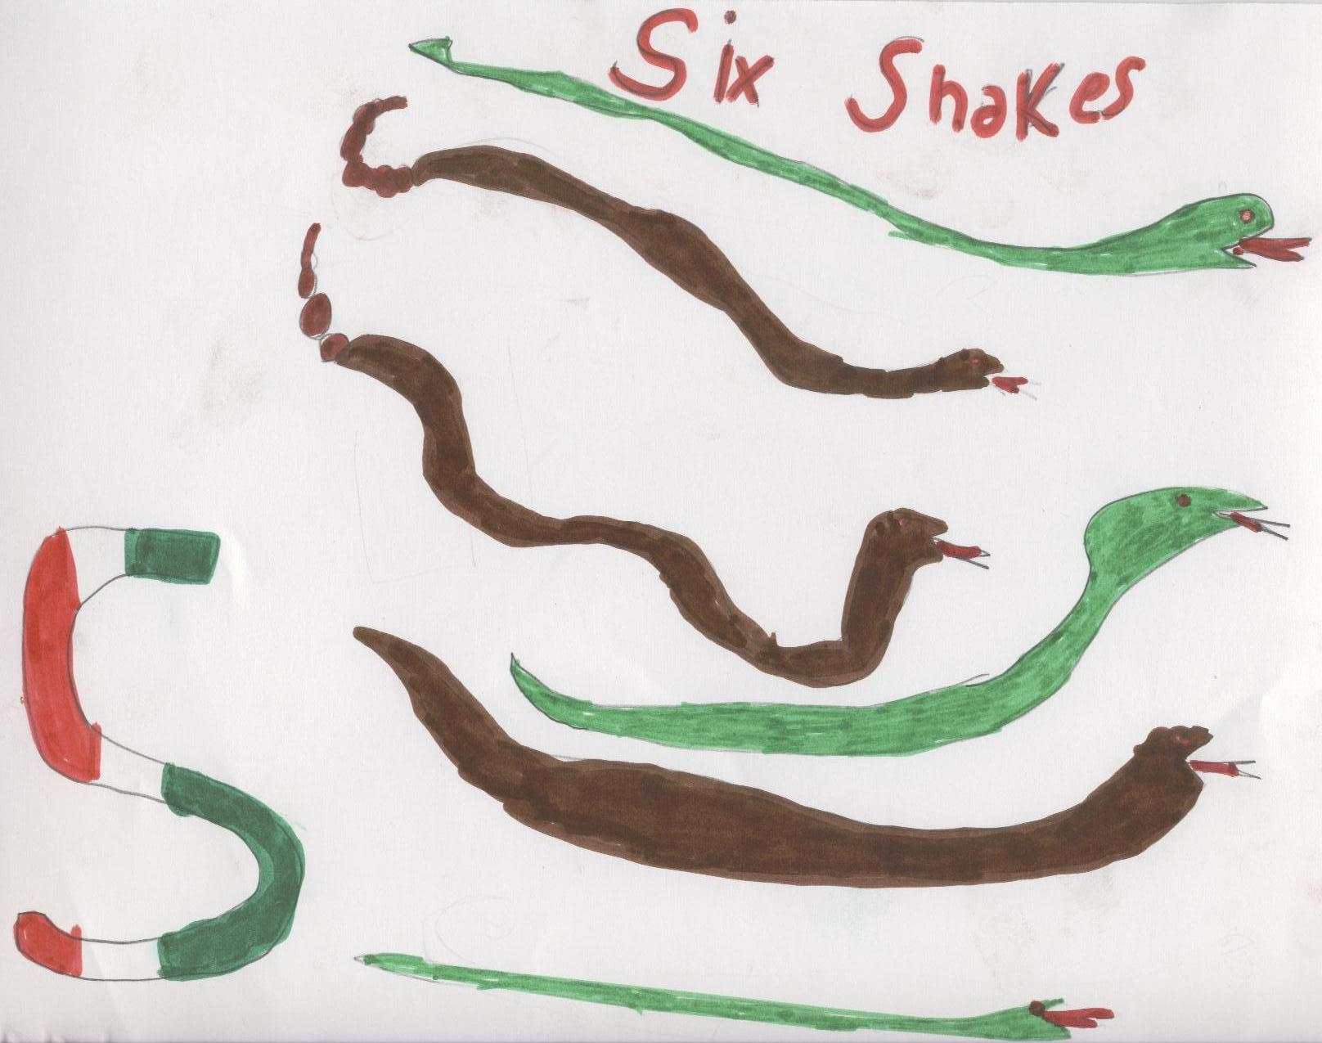
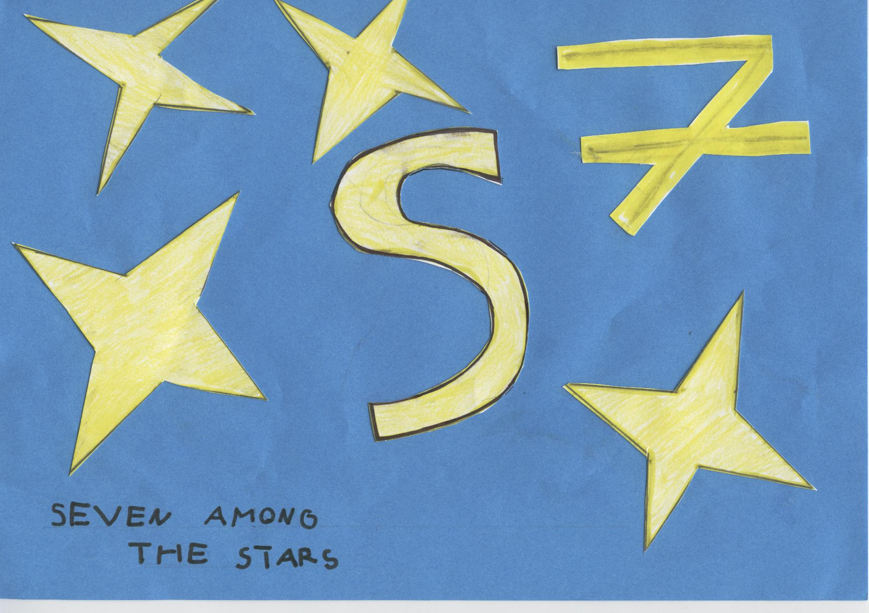
By children

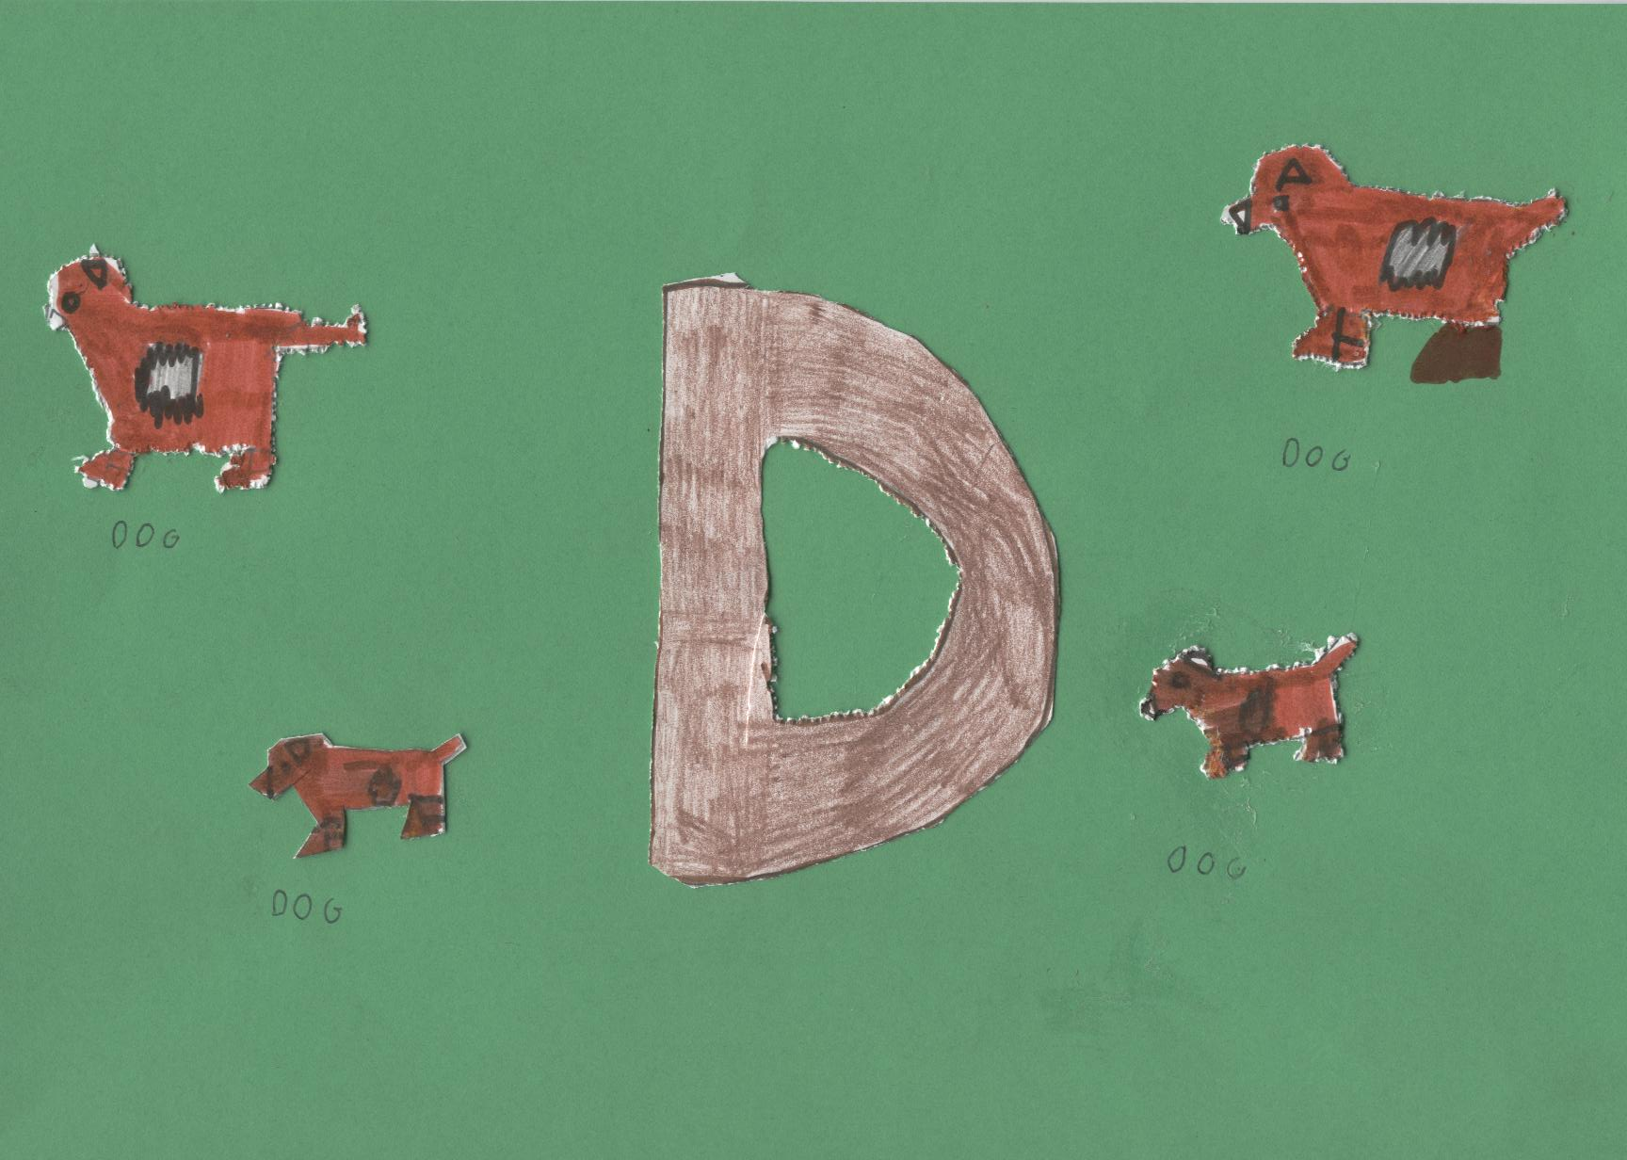
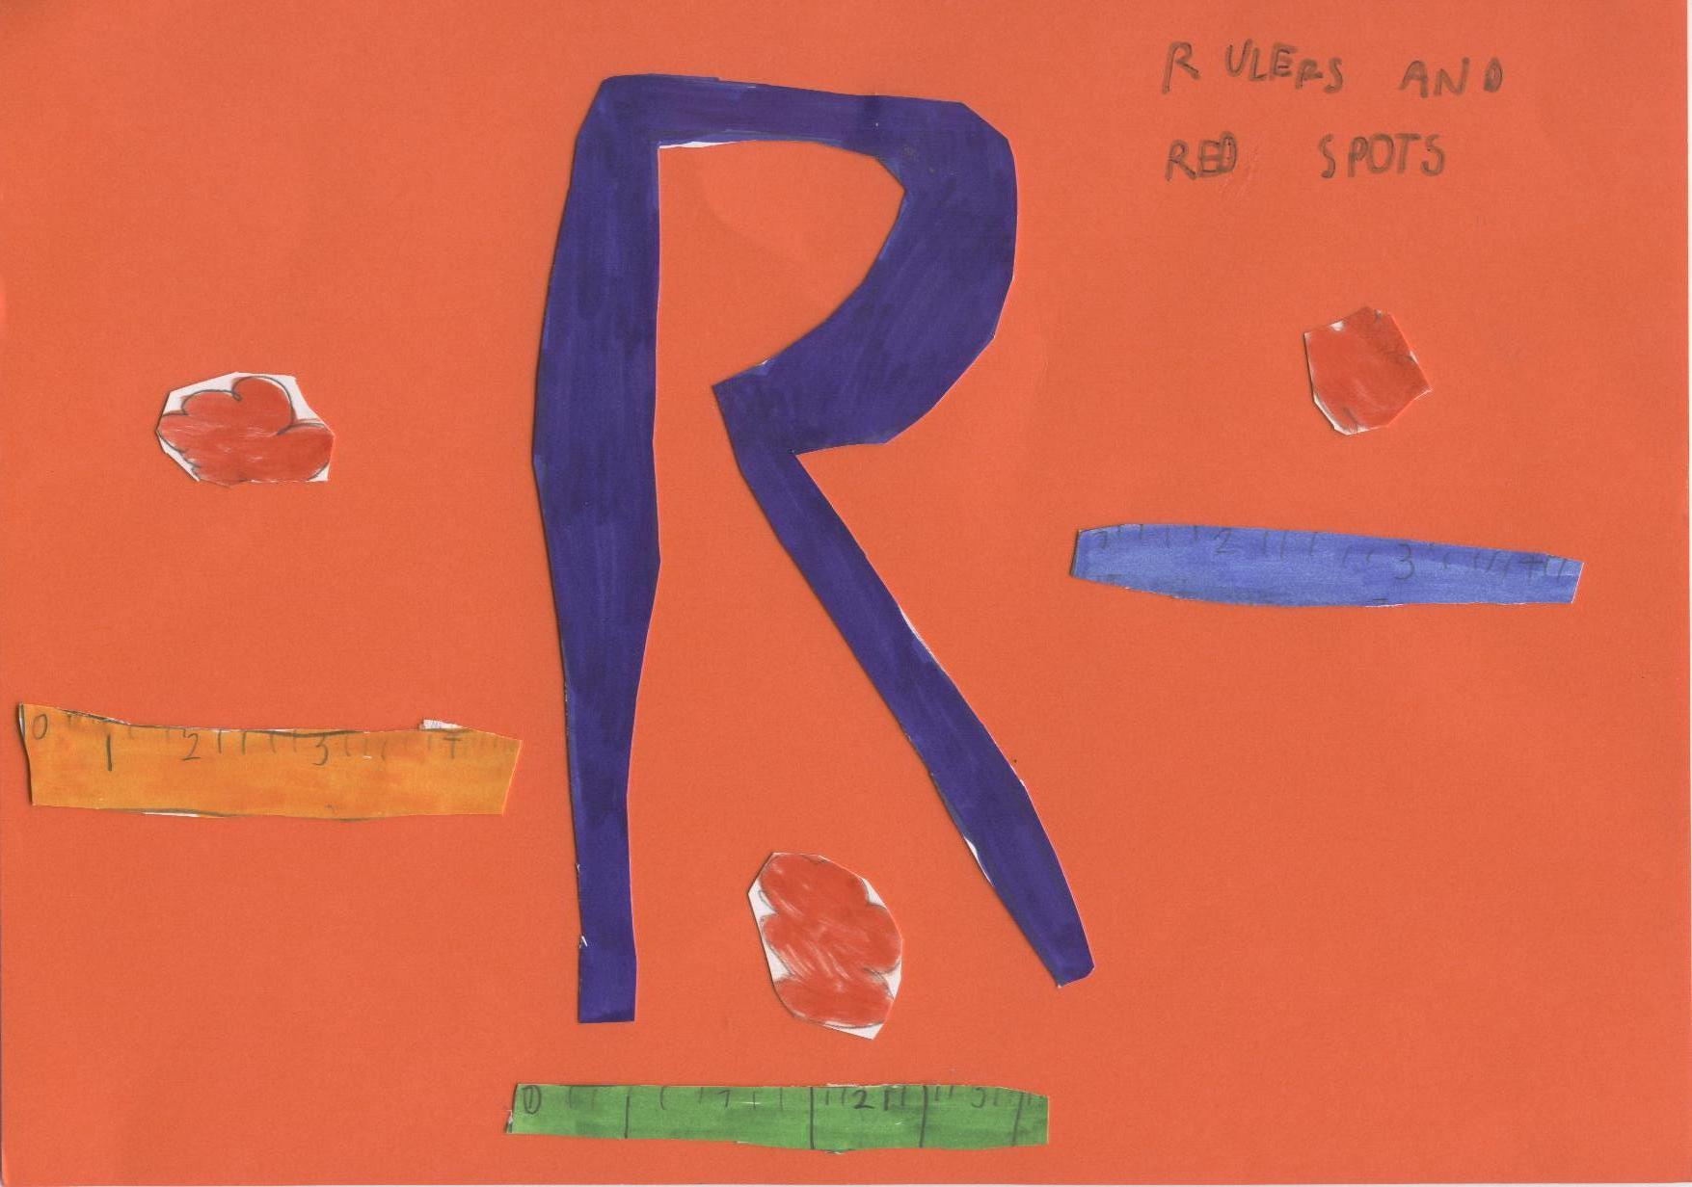
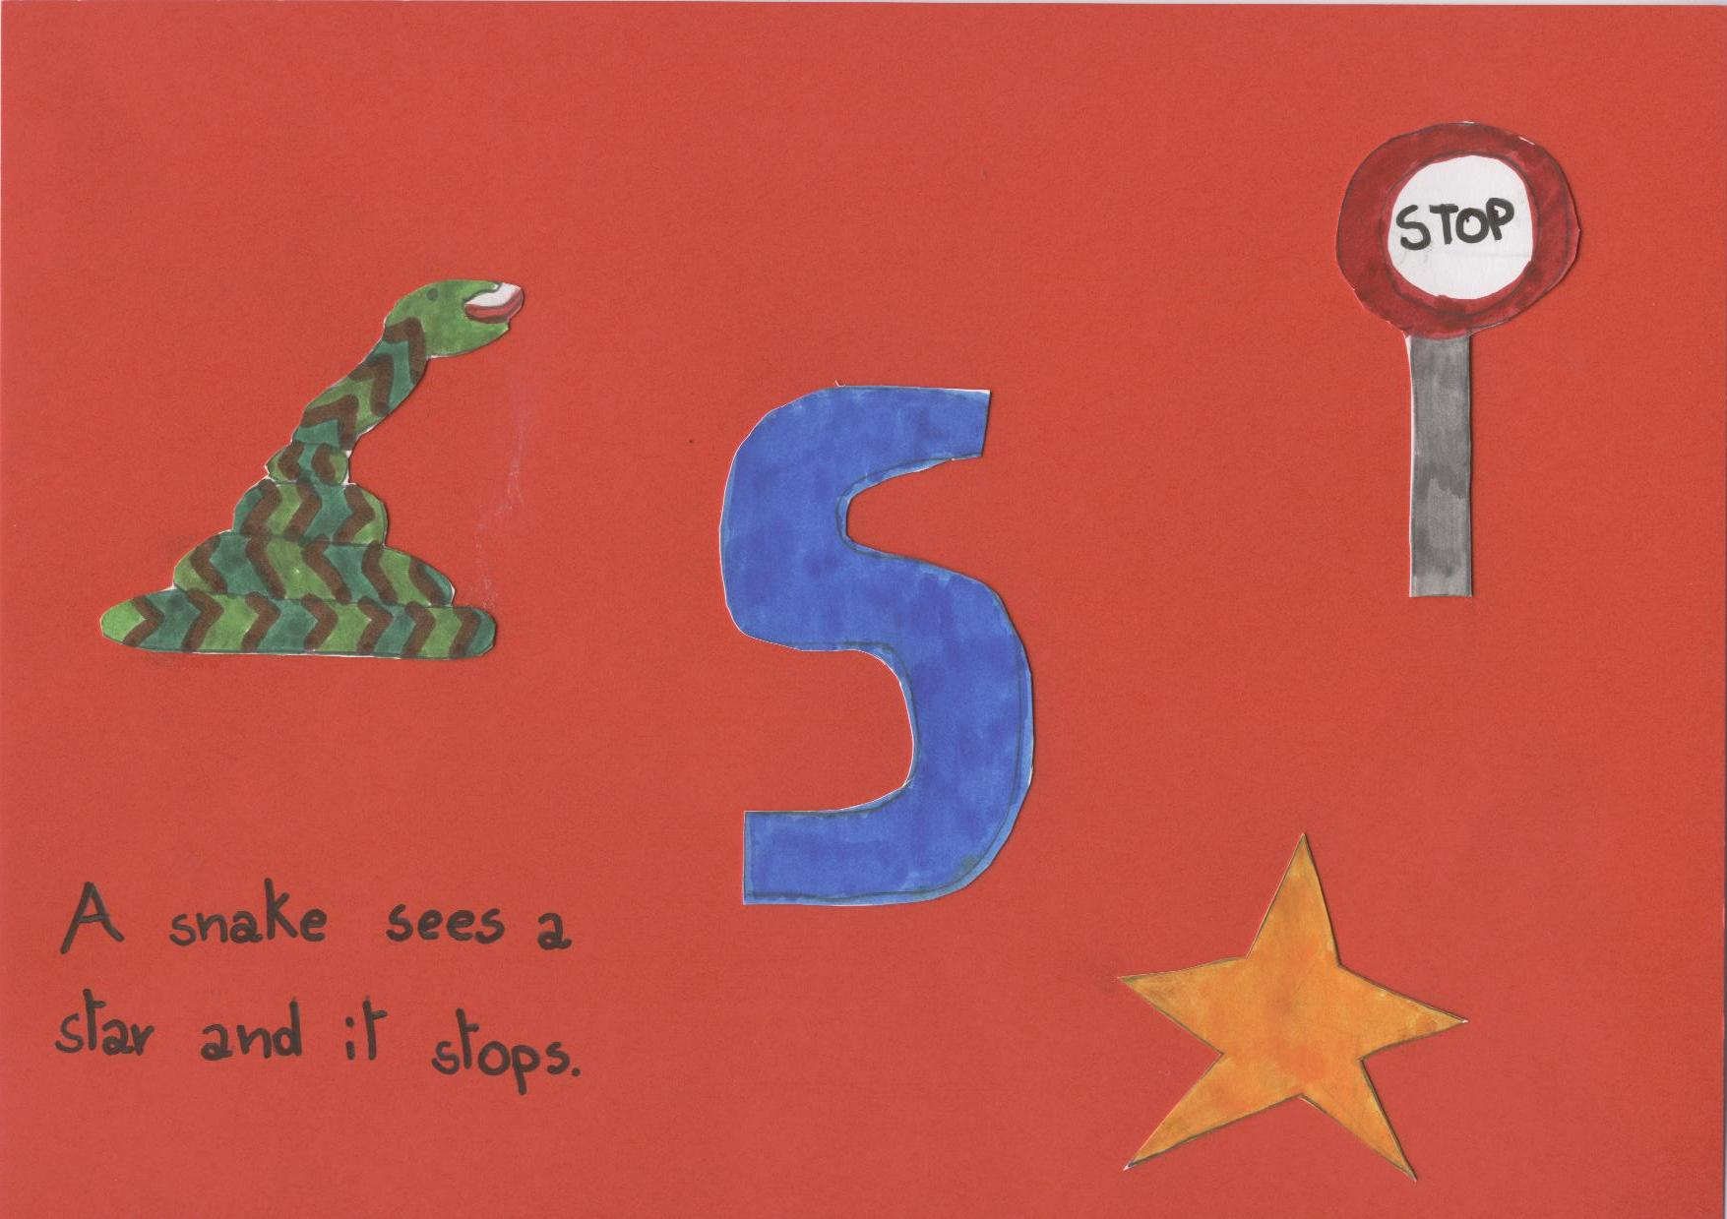
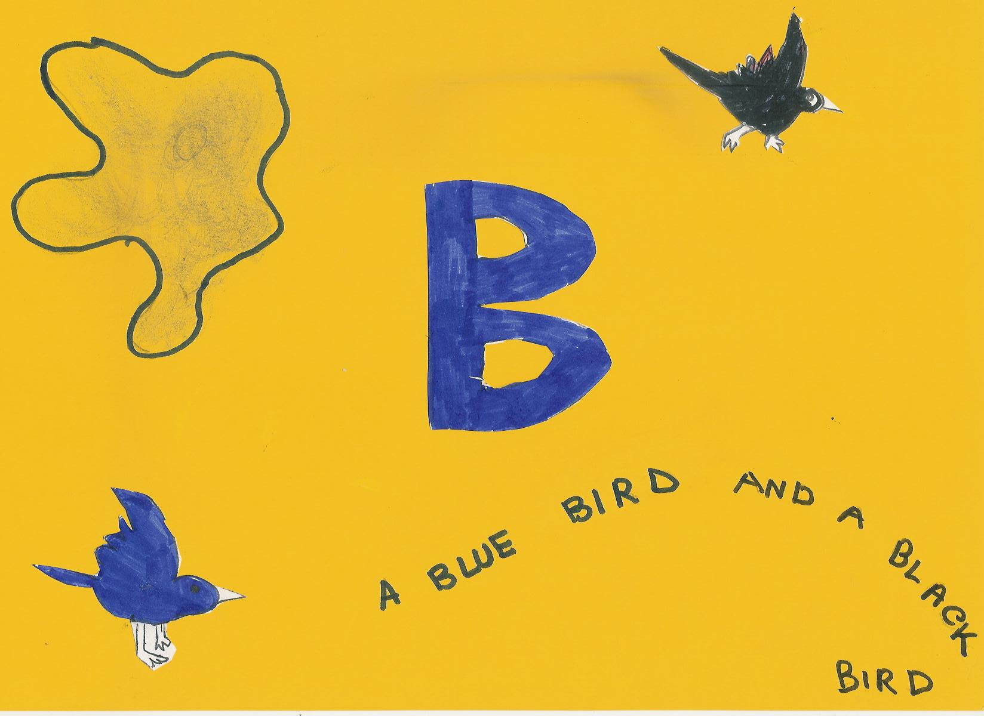
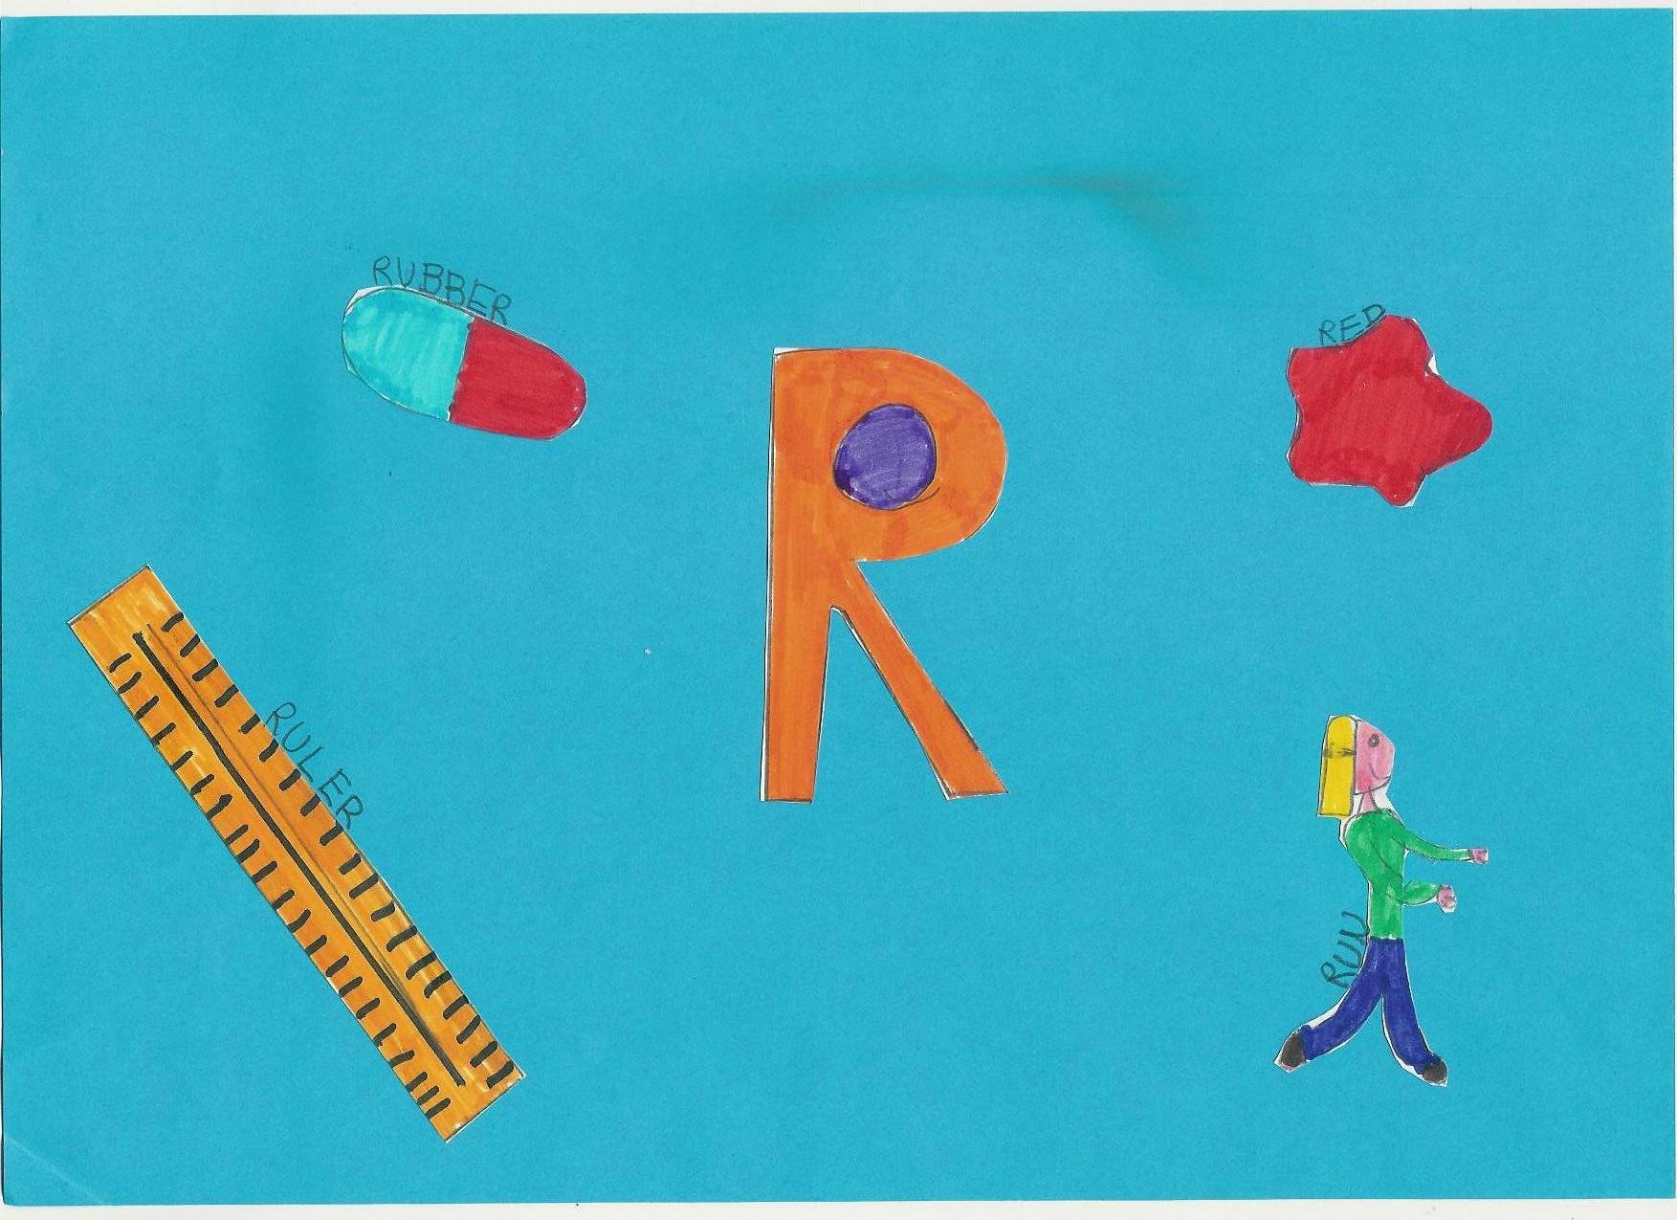

By children

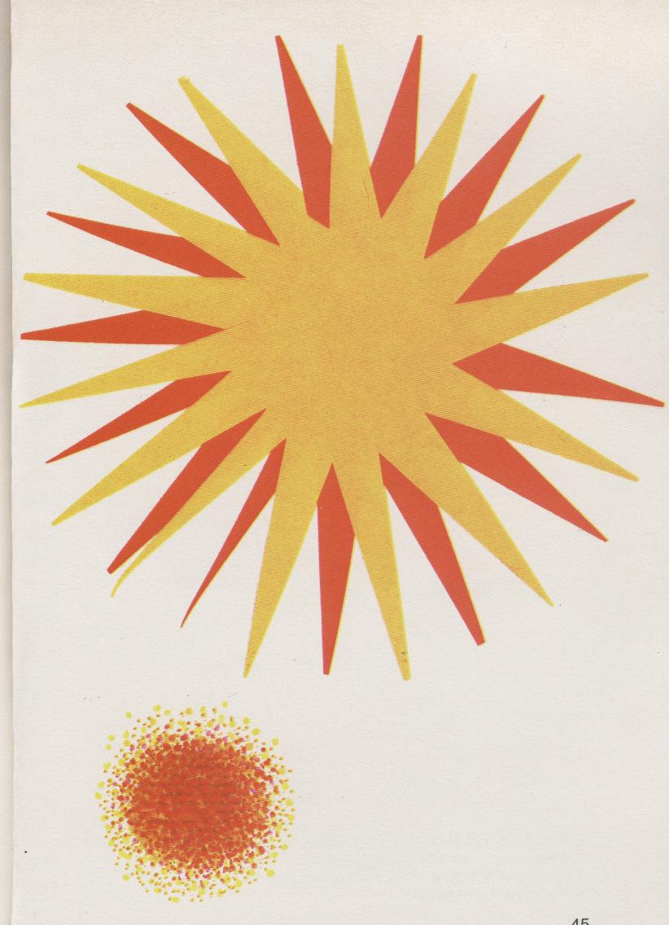
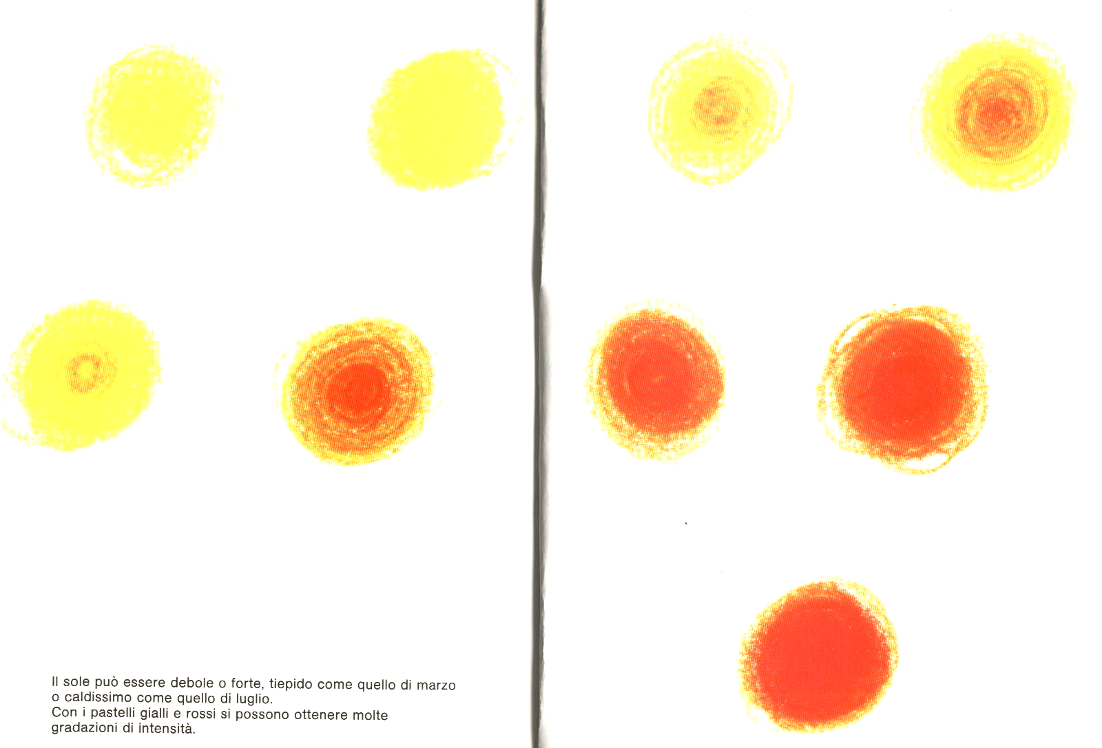
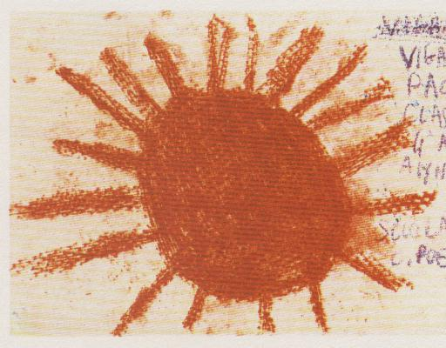
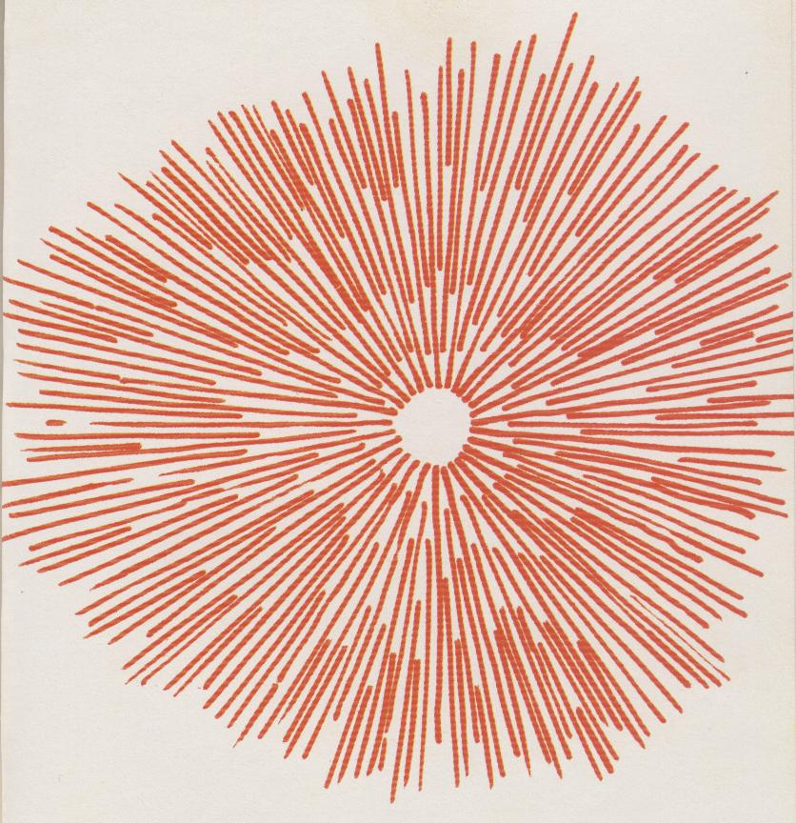
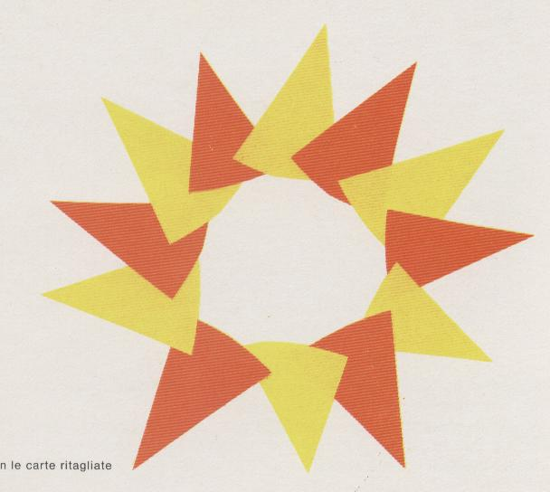

The sun can be weak or strong, lukewarm like that of March or very hot like that of July.
We can make a lot of shades using yellow and red crayons.
- Cut two sheets, one red and one yellow.
- Make a lot of little spots, one on the other.
- Use a big red crayon over a rough paper.
- Draw a ray at a time using a thin felt pen.
- Stick red and yellow triangles.
A.
C.
B.
D.
E.

We … in the same way like Munari
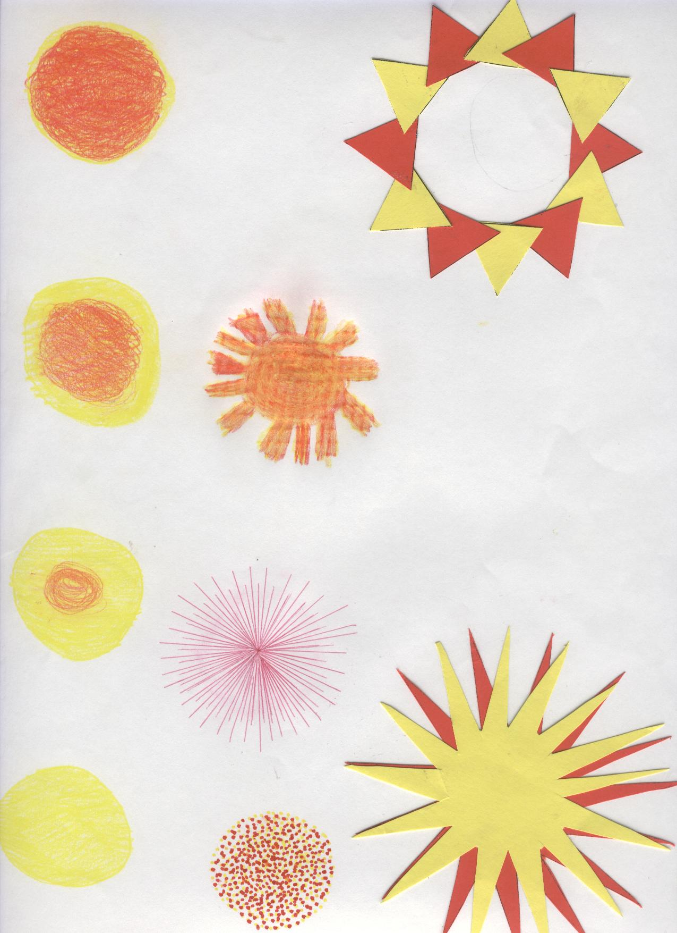
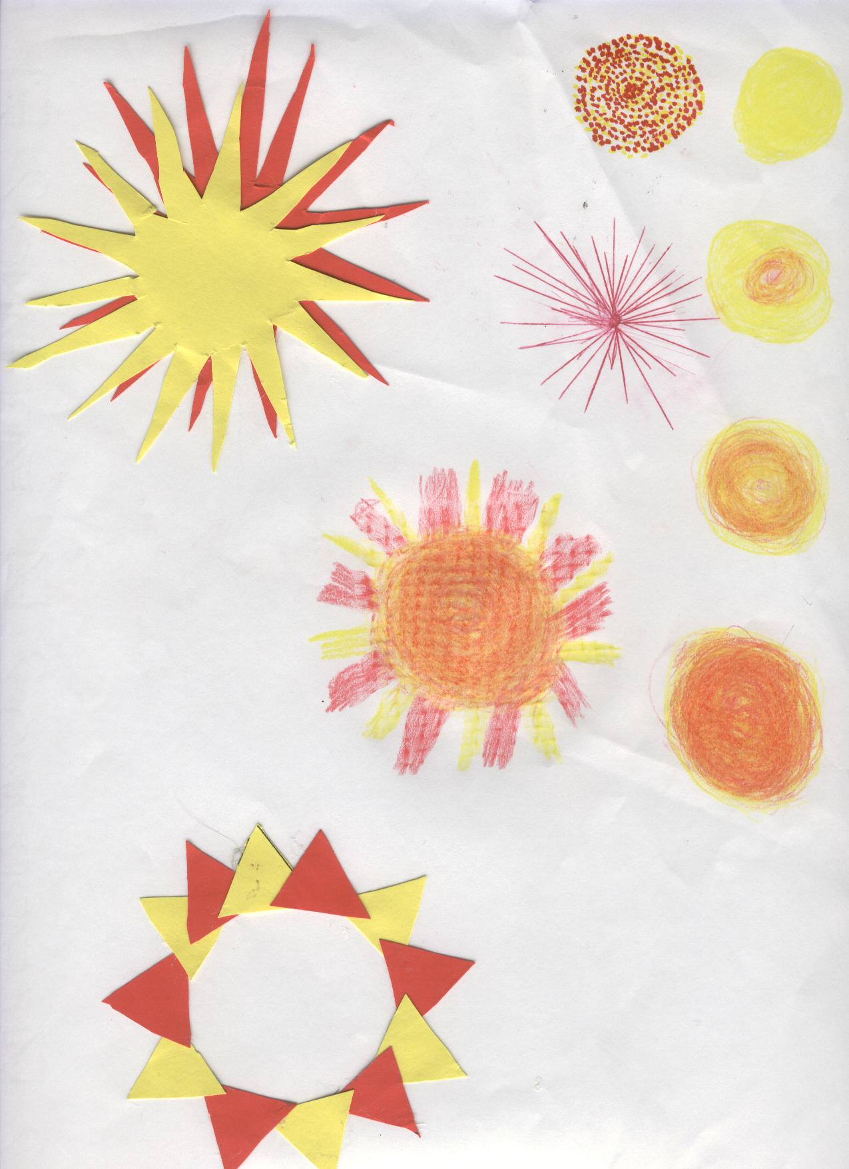

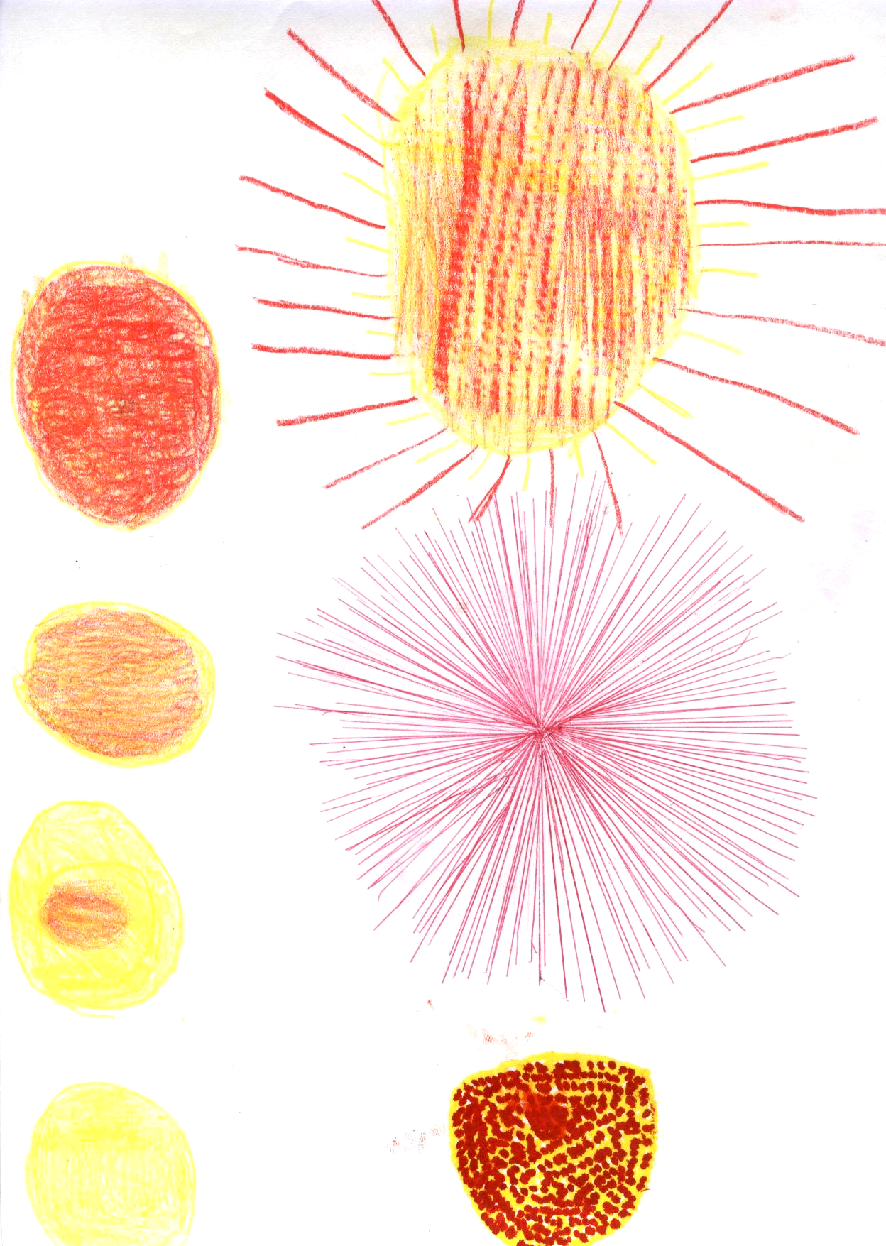
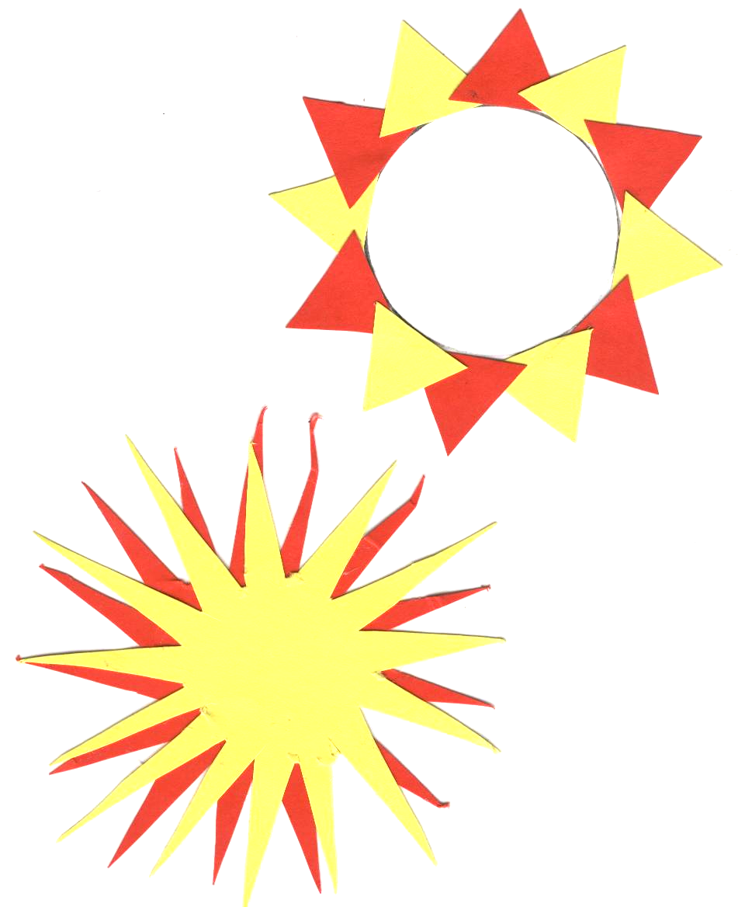

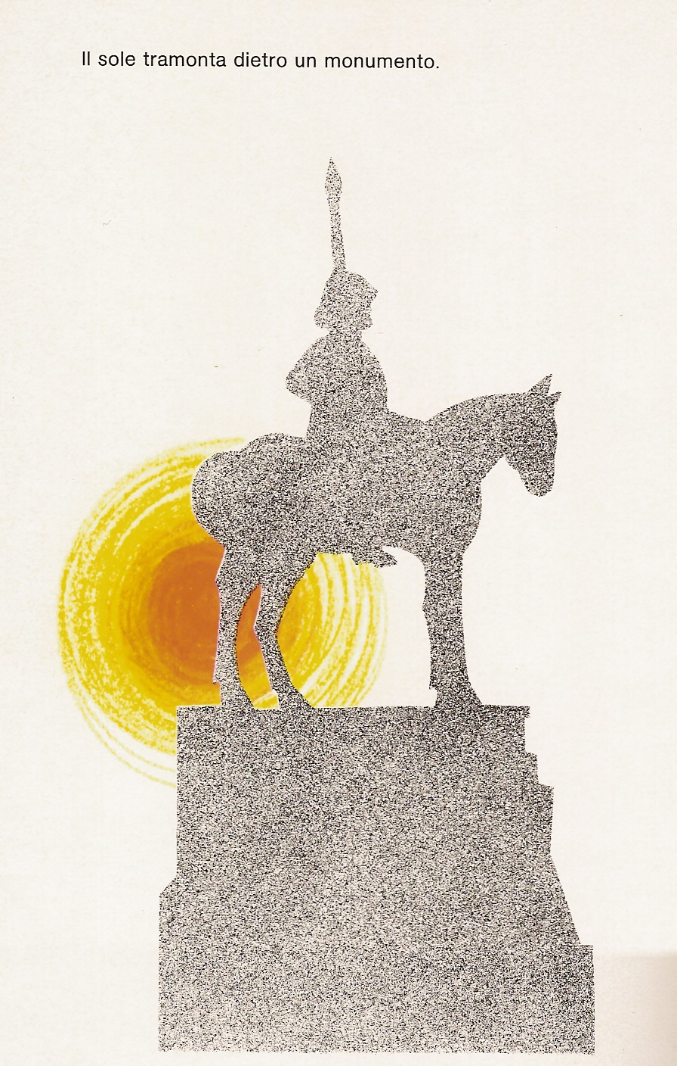
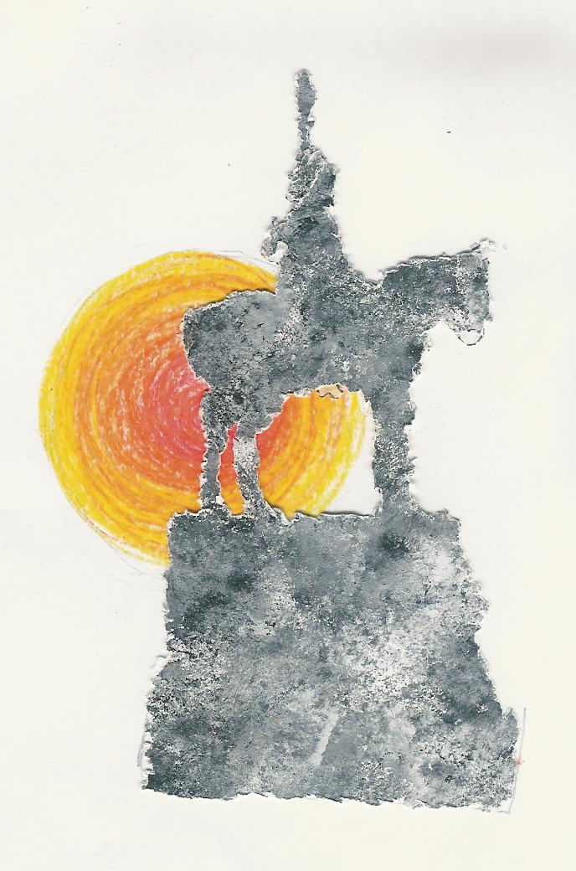
By Munari
The sun is setting behind a monument.

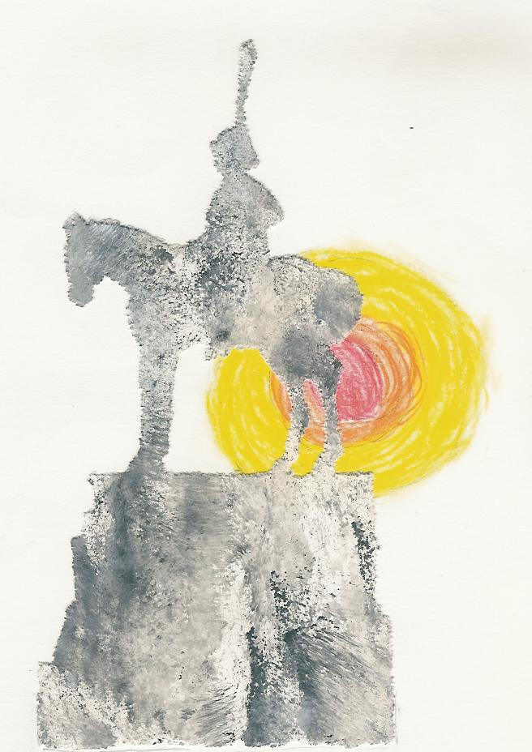
By children

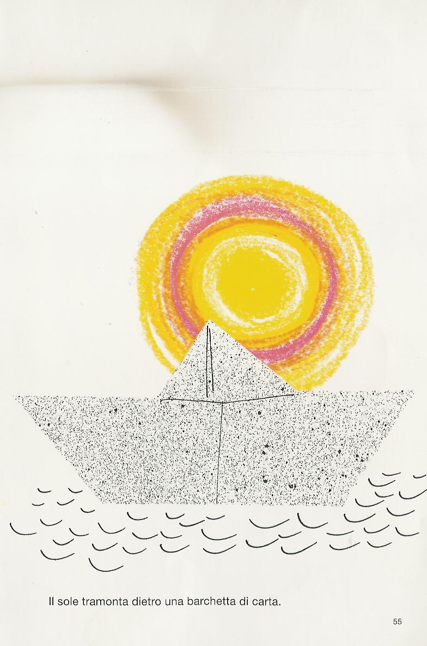

By Munari

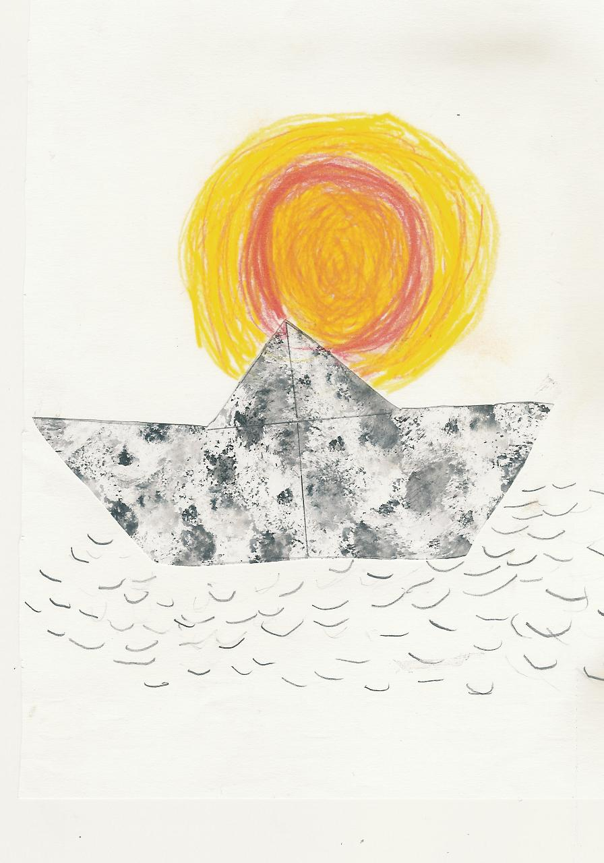

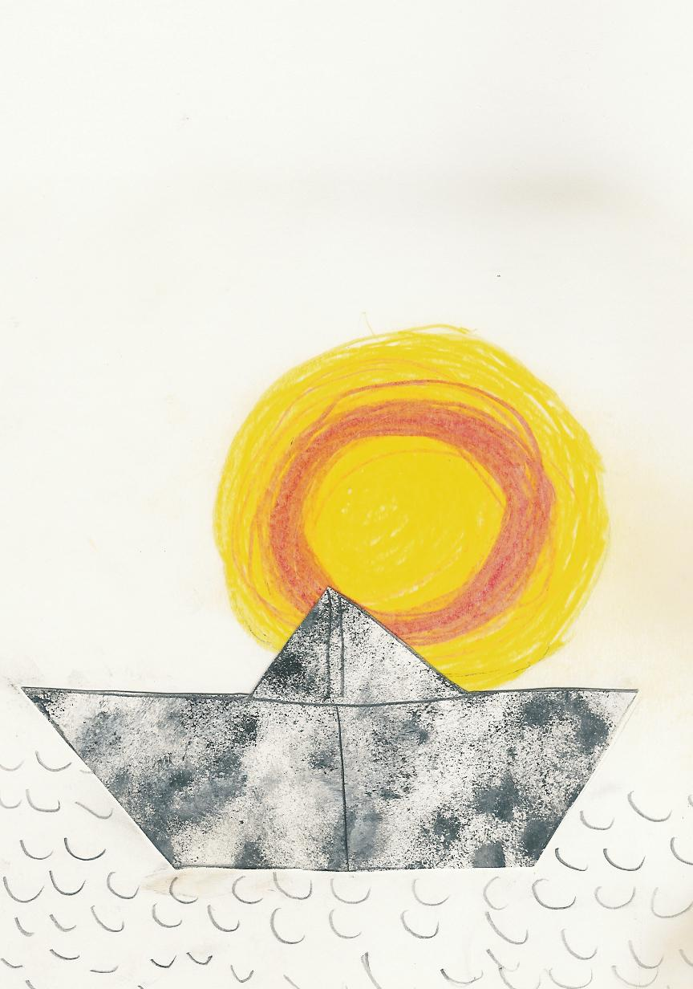
The sun is setting behind a paper sheep.

By children

By Munari

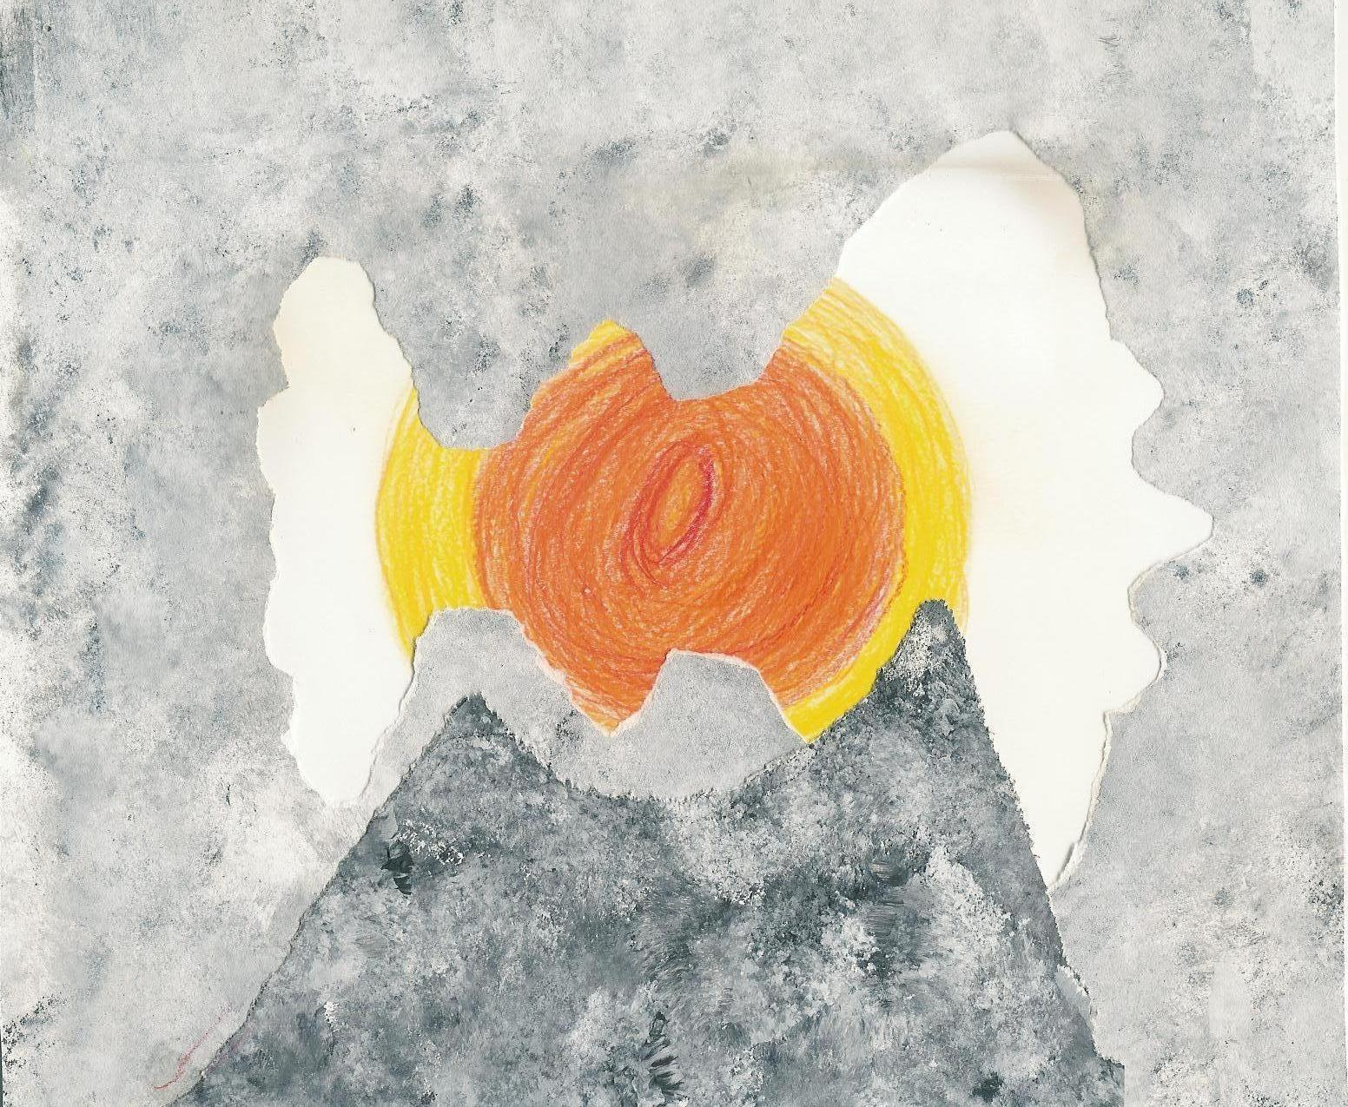
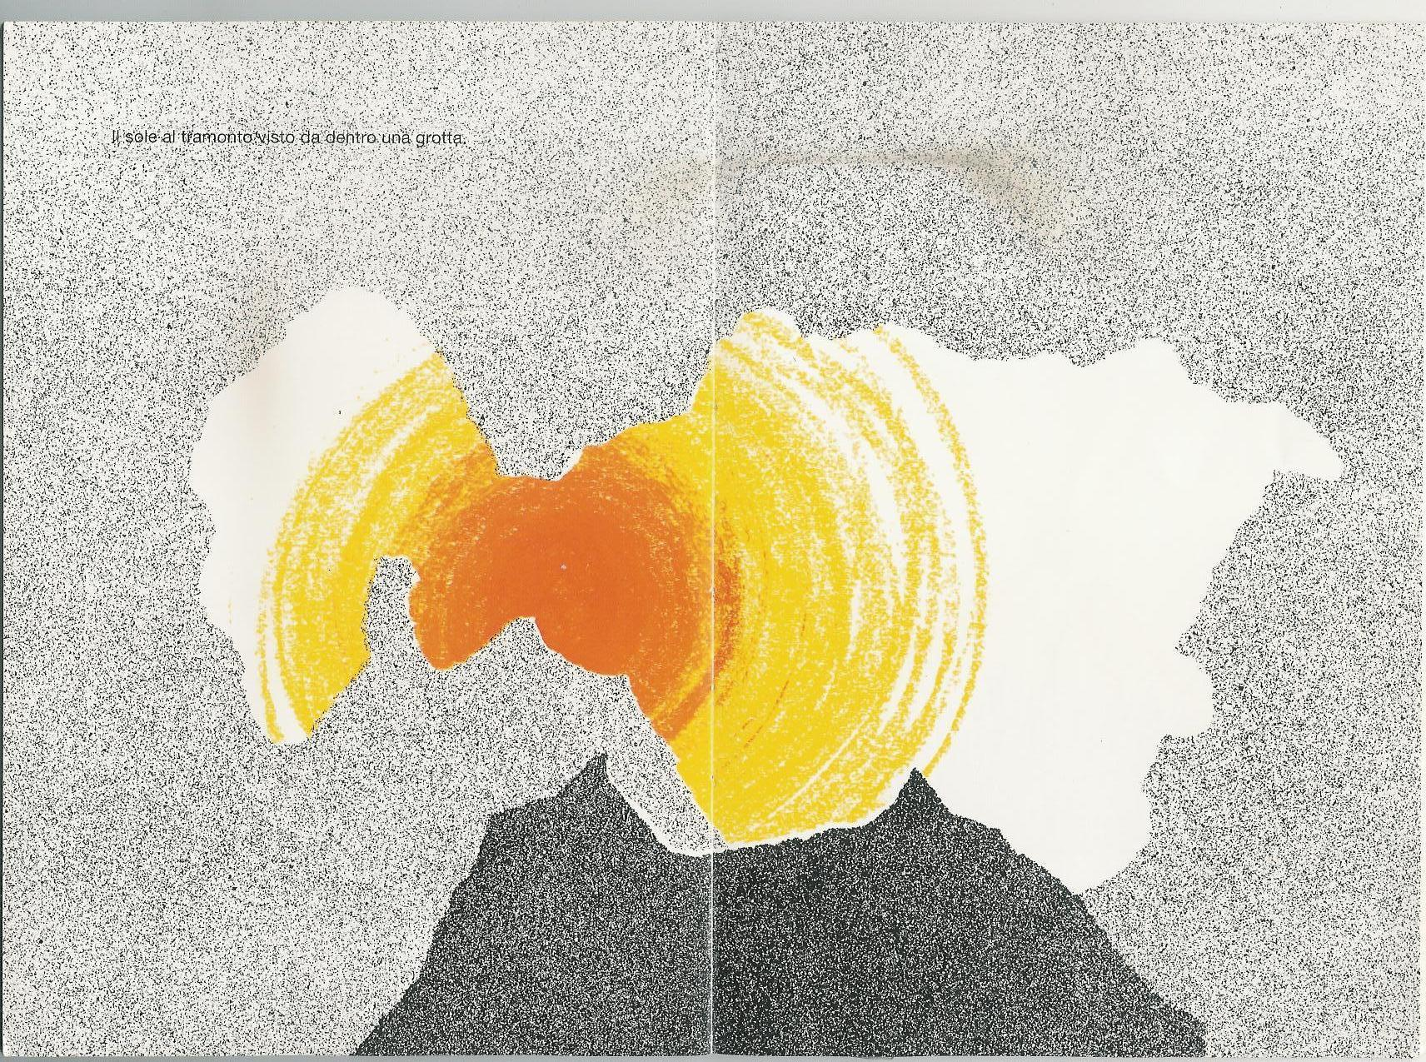
I am in a cave and I am looking the setting sun.

By children
By Munari
The sun is setting in the city too.
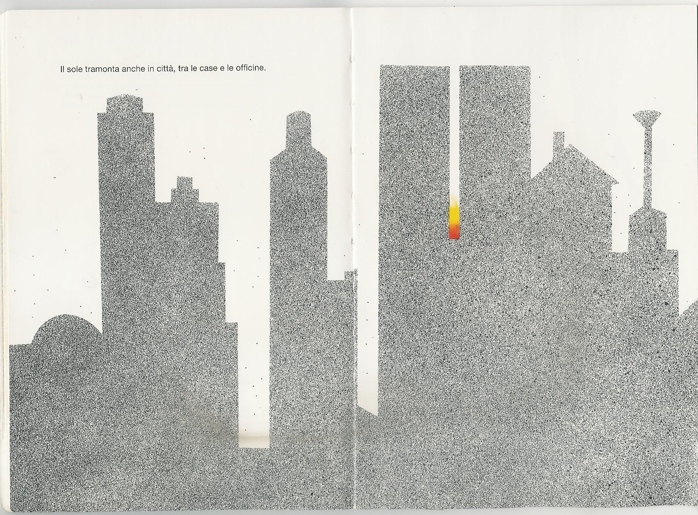

By children
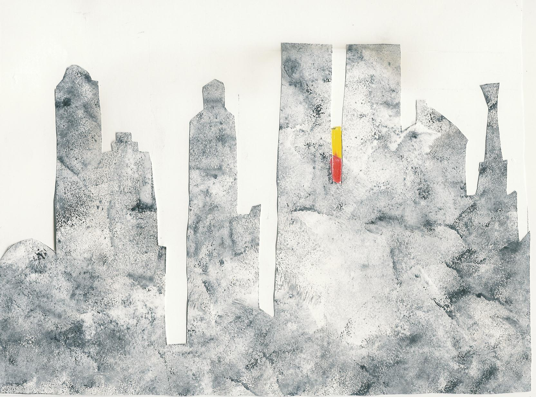
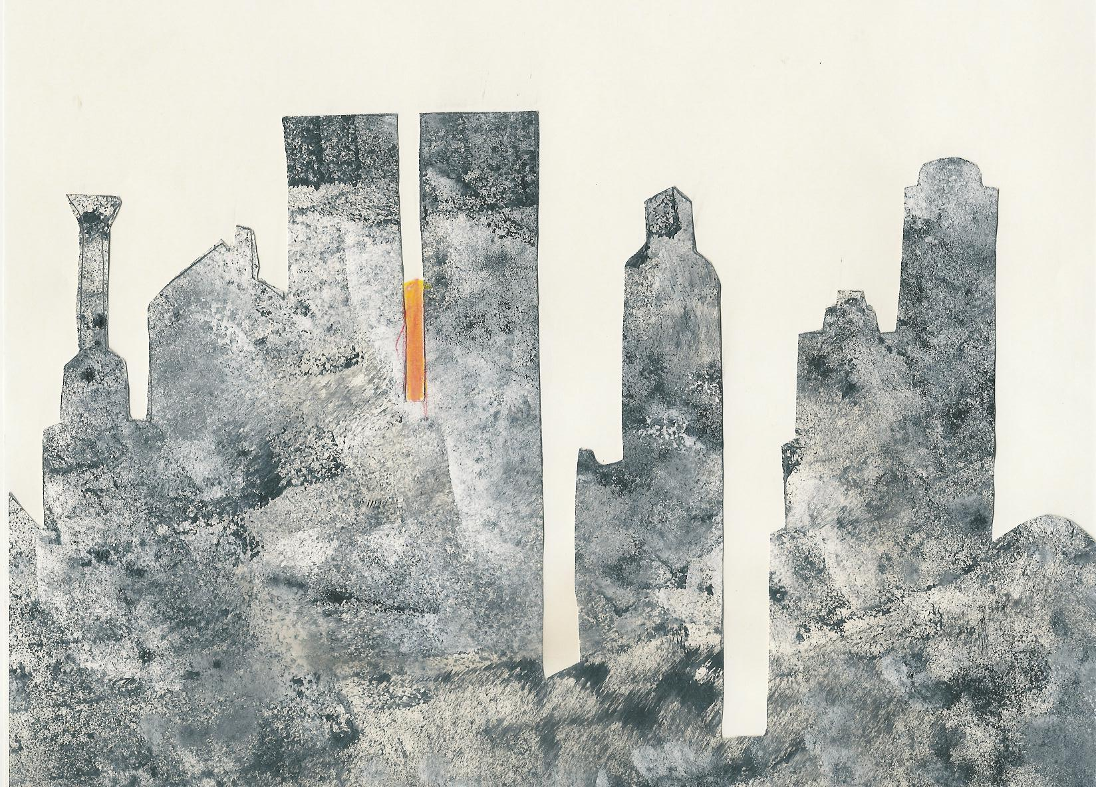

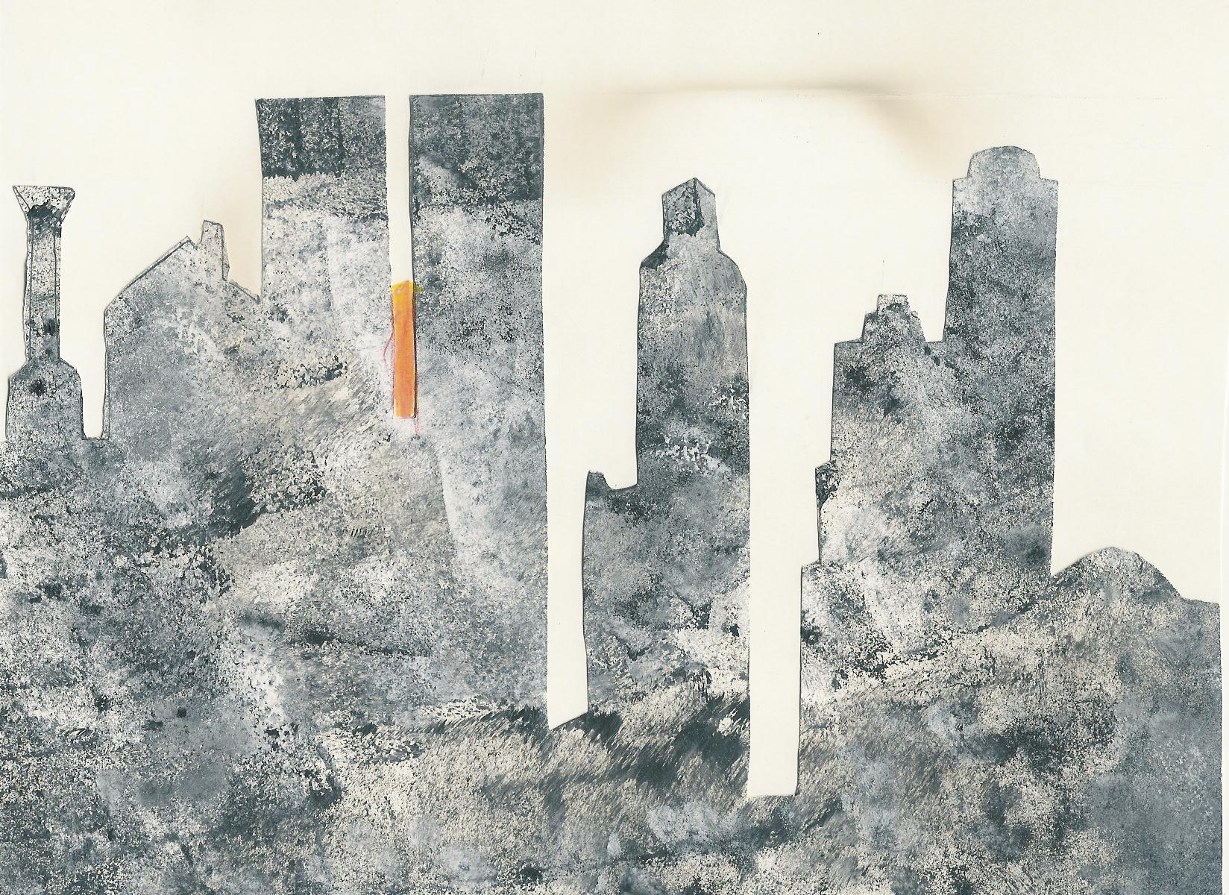

By Munari
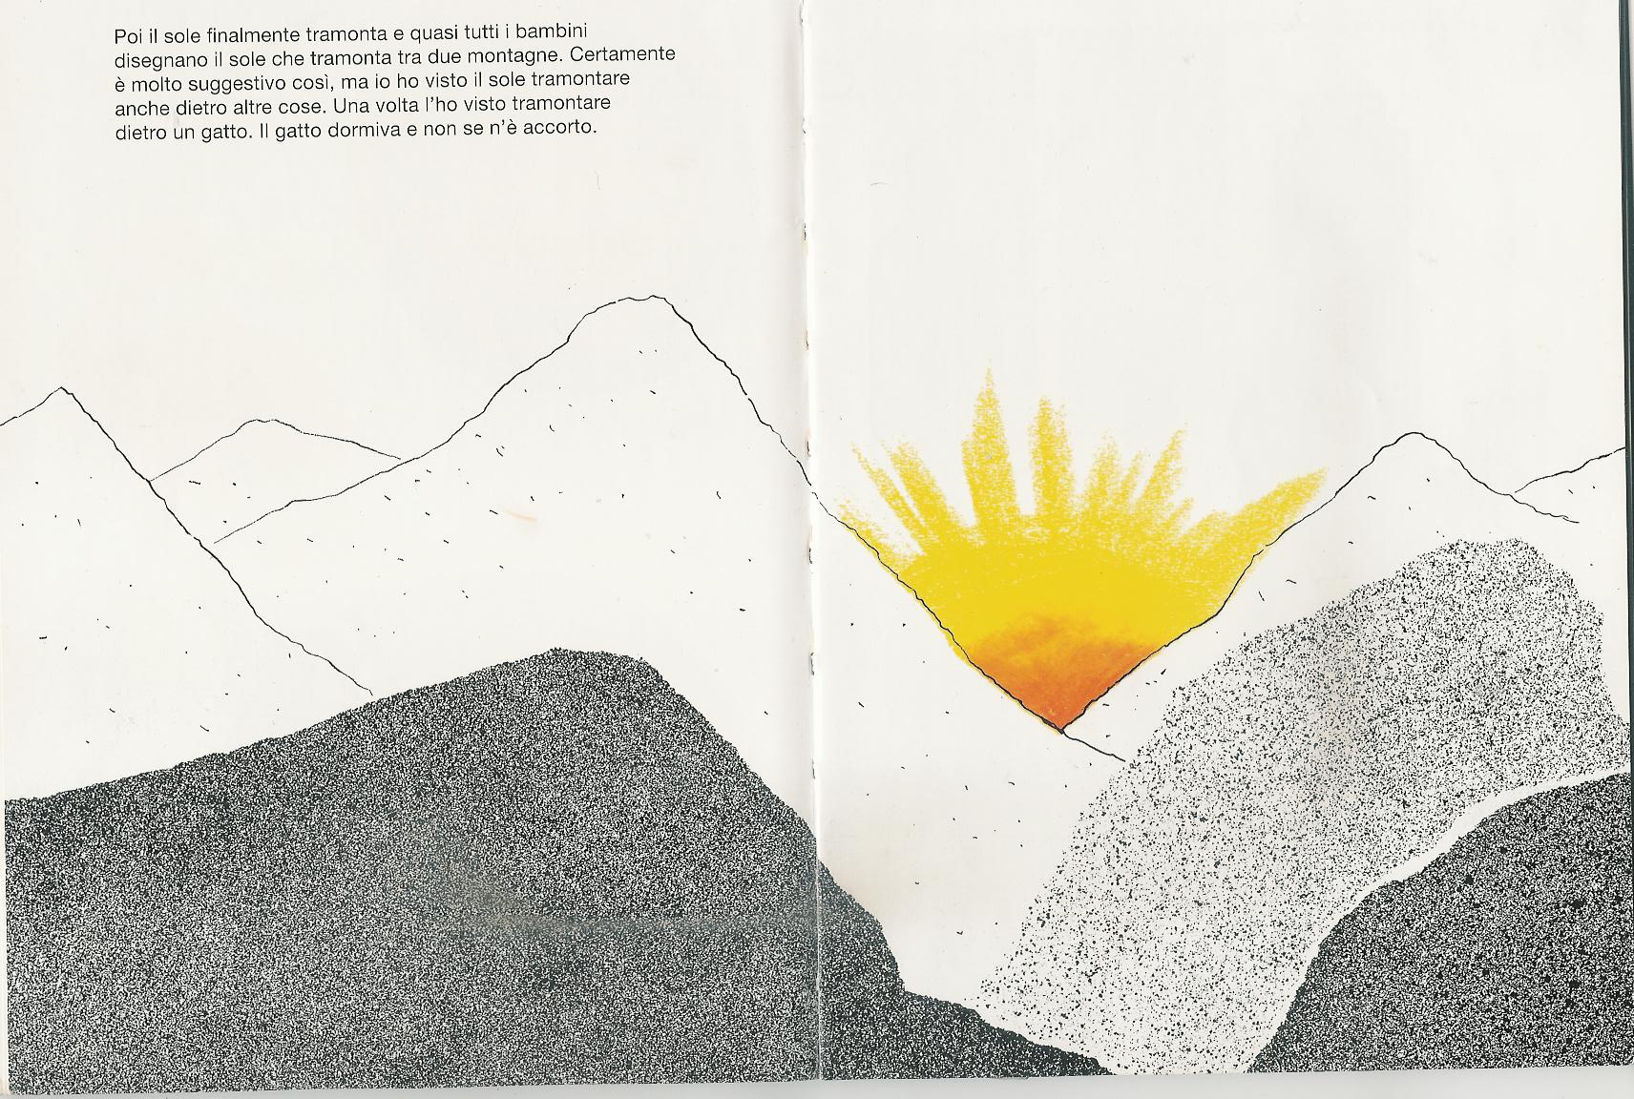
At last the sun is setting between two mountains.

By children
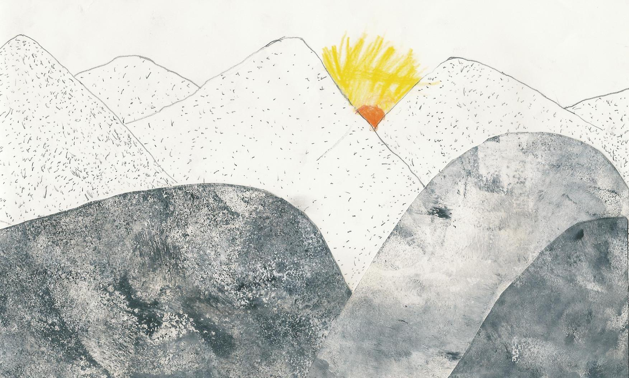
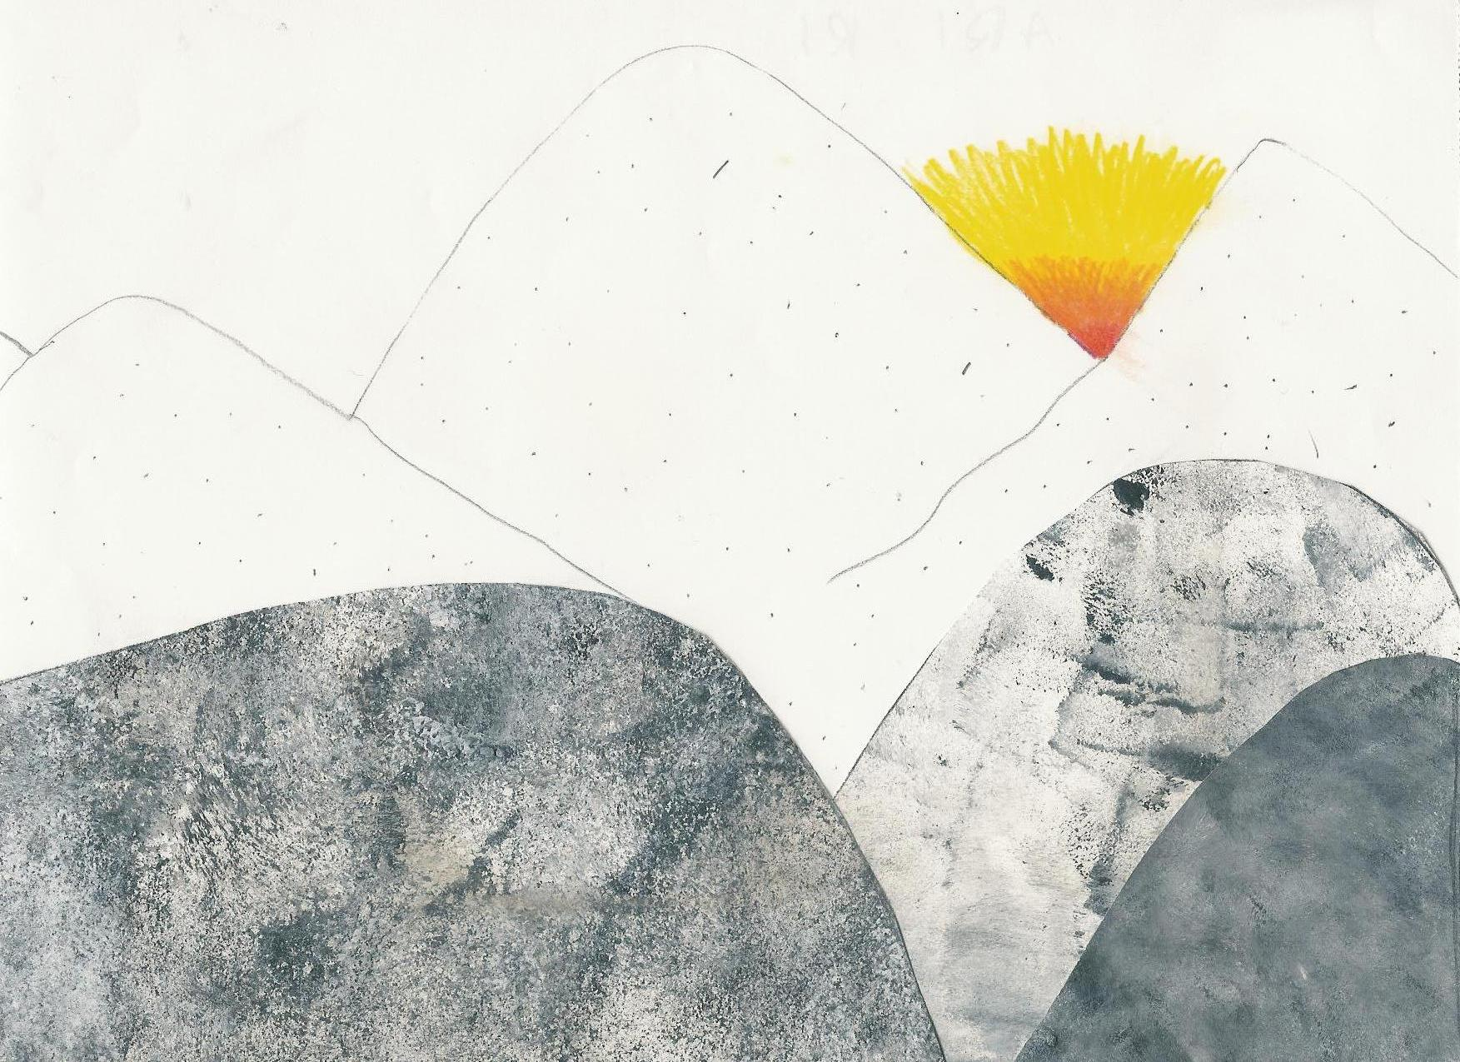

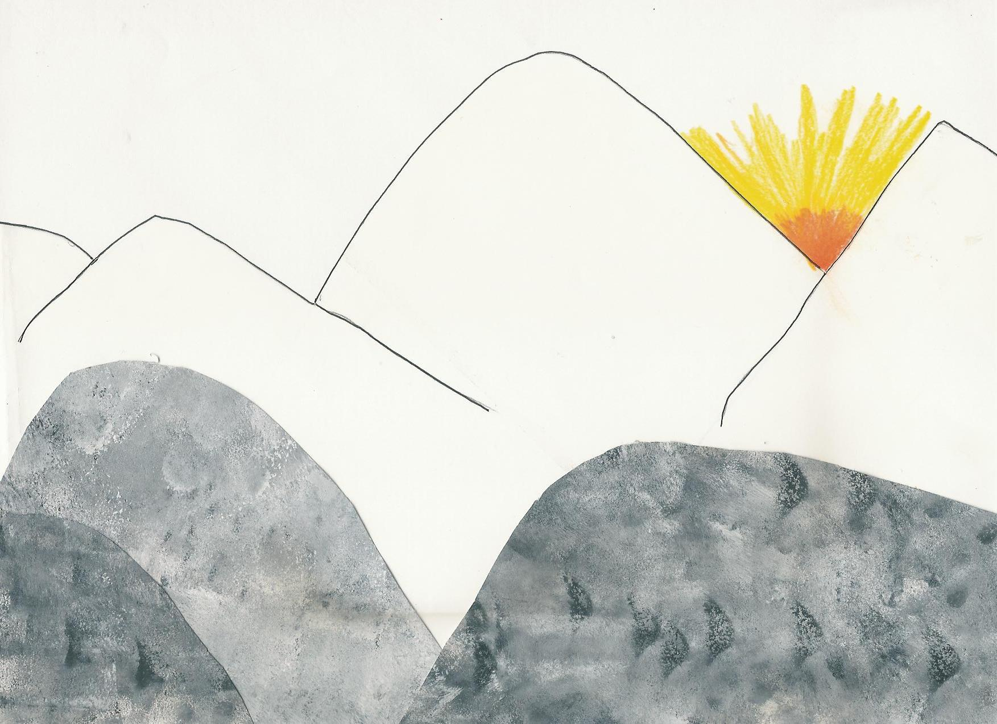
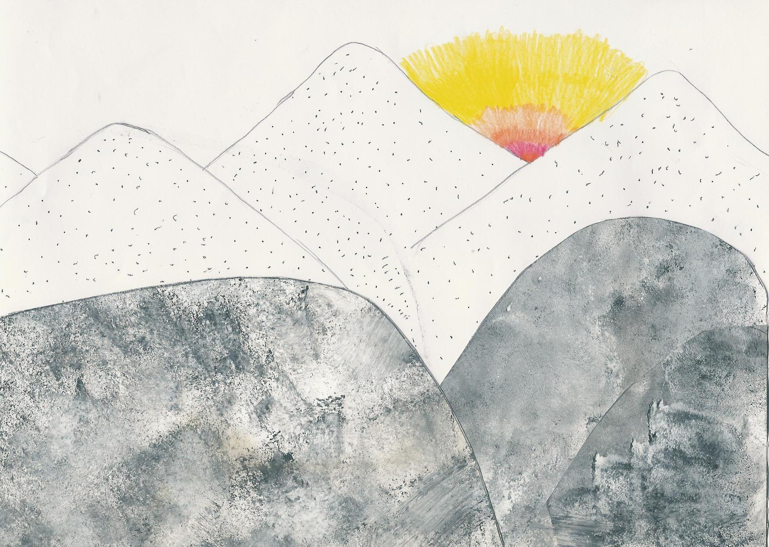

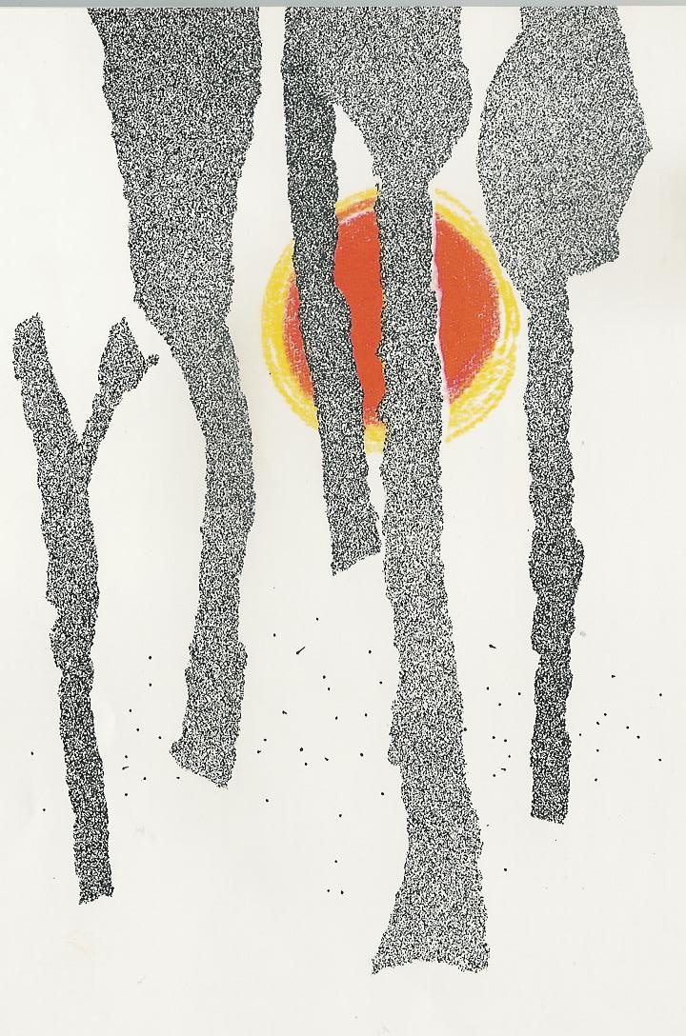
The sun is setting behind the trees.

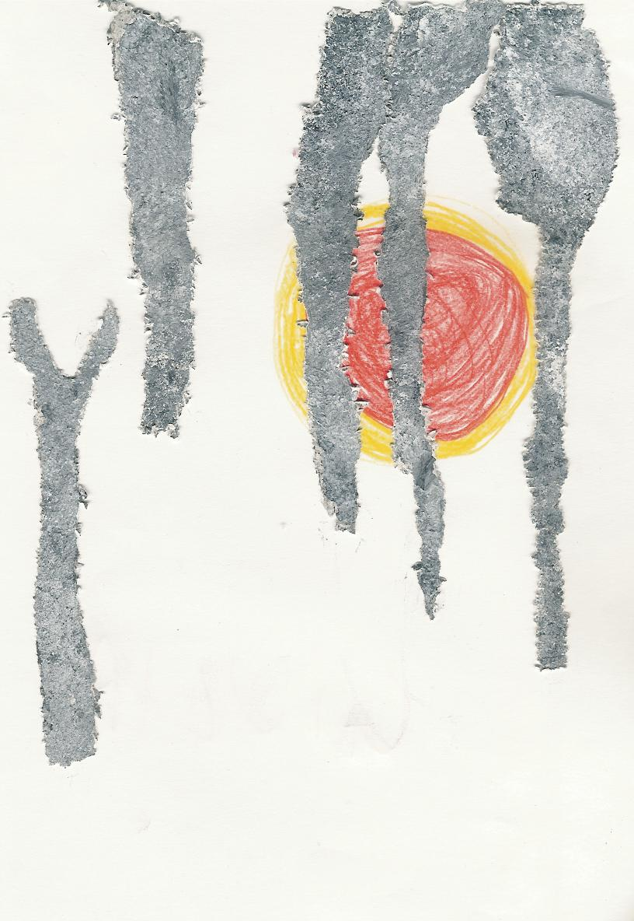
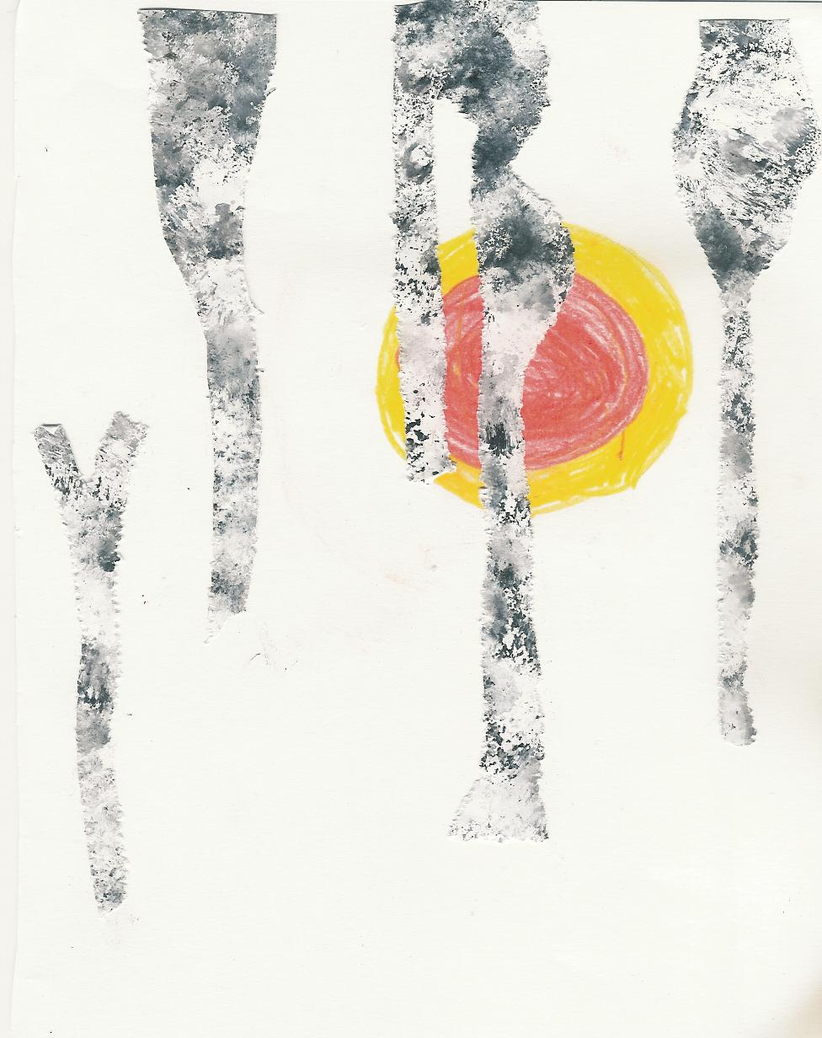

By children By children
By Munari

ANOTHER BOOK!
By Munari

By children


