046  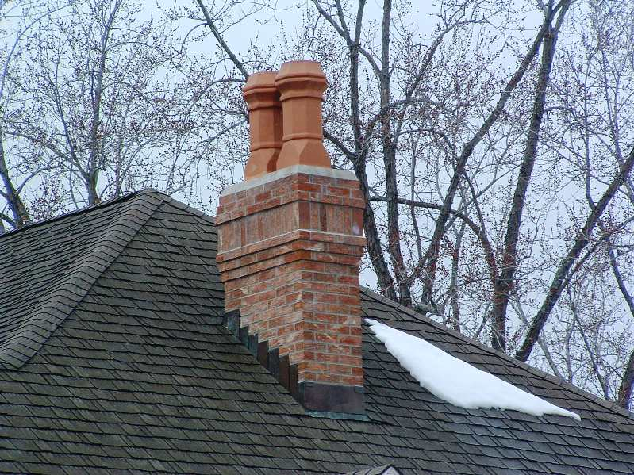 | 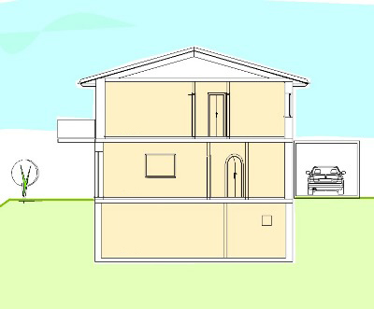  047  1  2  3 | 048  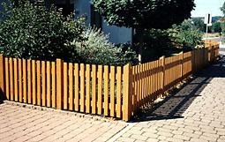
  cheminée | 1 premier étage  2 rez-de-chaussée  3 sous-sol | palissade
chimney  fence | 1 first floor  2 ground floor  3 basement
simne  ffens | 1  2  3 islawr
şemineu | 1 etaj  2 parter  3 subsol | gard
camino | 1 primo piano  2 pianterreno  3 sotterraneo | recinzione
Kamin | 1 erster Stock  2 Erdgeschoss  3 Untergeschoss | Zaun

