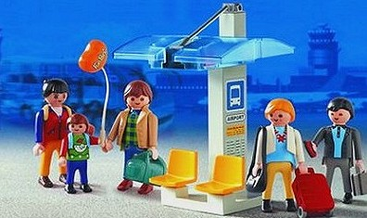
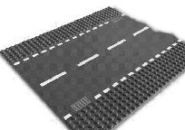
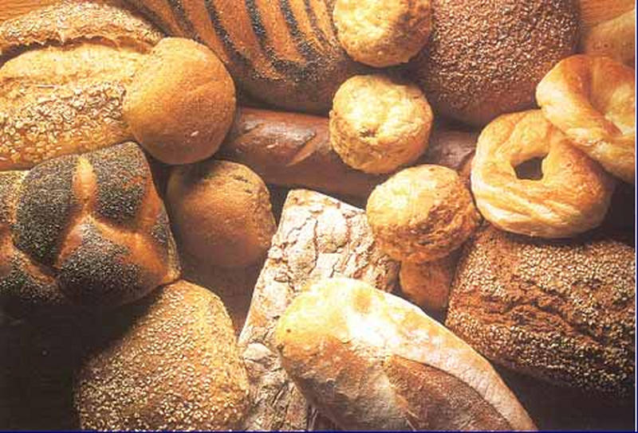
l
pain
arrêt de bus
route
bus stop
road
bread
safle bws
heol
bara
fermata del bus
strada
pane
staţia de autobus

strada

pâine

22
23
24
Bushaltestelle
Straße
Brot


